Systems Analysis and Design
Online Gold Loan Application
OGL

Prepared By ANUMOL JAMES (100880)

Version:.1.2
Date: 27/12/2025

Version | Date | Author | Change Description
1.2 | 06/08/2025 | ANUMOL JAMES | Document created
1.3 | 27/12/2025 | ANUMOL JAMES | Document Modified

Table of Contents

Revision History and Changes 2

1.Introduction and Purpose 3
2 Naming Conventions 3
3 Functions of the system and Business Requirements. 4
4 Project code and TFS Locations 6
5 Deployment and Testing 6
6 Process Analysis 6
7. Screen Design and Descriptions 8
8. Data Base Schema Design 53

Introduction and Purpose

1.1 Purpose of Document

This document is intended to communicate the design concepts, standards and approaches to be applied in development of OGL mobile App.

  - NOTE

OGL is an online gold loan app in android. It fulfill all financial needs. By using this app we can check our balance, make payments and get loans.

2 Naming Conventions

- Database Entities

Tables:
- TBL_ONLINE_FPASSWORD_OTPLOG
- tbl_online_customer_details
- tbl_language_rqst
- tbl_online_login_register
- TBL_ONLINE_CTRAN_ENTRIES
- tbl_online_tran_track
- TBL_OGL_PLEDGE_BLOCK
- TBL_ONLINE_OTP_LOG
- TBL_ONLINE_EXCEPTION_MSG
- TBL_PAYU_COMPLETED
- tbl_online_payu_trans_updation
Procedures:
- sp_online_queries
sp_ogl_queries
sp_online_transactions

2.2Classes and Objects

All classes and their objects will have meaningful names – as dictated by the object model
All the properties shall begin with a camel case letter

Class and Object: Password Class and Helper

2.3 System requirement

2.3.1 Server Side

- C#.net (VS 2017)
- Oracle. Managed Data Access

2.3.2 Front End

- Android studio

2.3.3 Testing

- Unit Testing - Visual Studio

2.3.4 Applications/IDE used

- Visual studio 2017
- PL SQL Developer
- Android studio

    - Visual Studio Solution Structure

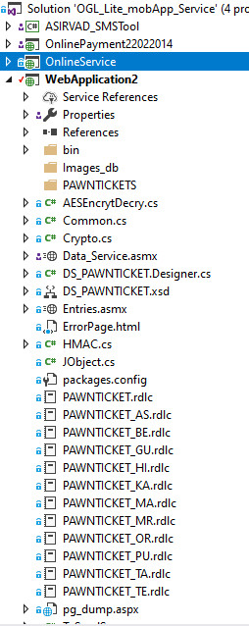

Functions of the system and Business Requirements.

3.1. Functions of the system

Registration – Customer need to register the app first by providing customer Id, mobile number and email id
MPIN SETTINGS – Customer can set MPIN for login.
Login – Customer can login by either normal login (customer Id/mobile number/Email ID and Password) or MPIN
Forgot Password & Change password – Password can be changed through this option. OTP verification exits.
Profile – Customer profile details can be seen here
Transaction History – here get the transaction report (interest payments and partial payments) between two dates.
Pledge History & Download Pawn ticket- From here we can download the pawn ticket and get the pledge history between two dates.
Interest Payment –If the customer has interest due, then the amount will be displayed here and customer can proceed with this for interest payment.
Make payments- using Pay U gateway we can make payments through debit cards, online banking and UPI transactions
Re Pledge - Customer can re pledge in any of the eligible scheme. Pledge details with interest rate, tenure, and amount will be displayed to review the details.
If the customer interested to do re pledge, then he can proceed by accepting the” terms and conditions”. OTP verification needs to confirm the repledge.
One Time Registration- Through this page, we are able to verify the user bank account for their loan disbursement.

3.2. Business Requirements

The following are the Business Requirements:
Availability: A system that will maintain availability of 99.99%
Reliability: System that will maintain a mean time between failures of greater than 60 days.
Performance: System will have an average page load time of less than 2 seconds.
Throughput: The system will handle 1,000 concurrent users while meeting performance objectives.
Standards: The system will comply with the architectural and security requirements.
Authentication & Authorization: The system will confirm to the policy for authentication and authorization
Serviceability: Changes and upgrades to the system will not require total outages.
Maintainability: Logging will be sufficient to quickly identify and resolve system problems with a mean time to repair of less than one hour for high severity incidents.
Accessibility: All modules will have accurate closed captioning.
Privacy: The user interface will not allow all employees to view, verify customer data in the customer database.
Human Error: The system will detect any human errors and other device related errors while using the system and warns the user of the discrepancy.

System Errors: System errors will result in an error code that will be communicative to the user. This code will be well documented in the help desk system to expedite support and incident resolution.
Information Security: User credentials and all personally identifiable information will be encrypted in storage and transit.
Data: Customer data will be sources from the customer database without permanently storing these fields.
Data Quality: The data migration will confirm that the calculation are accurate for every customer.
Interoperability: The system will work on all major operation systems, devices and browsers as specified in the technology requirements.

4 Project code and TFS Locations

4.1. Front End: ftp://182.75.114.182/JUSSUIT/GL Branch/APK/
4.2 Back End: aml_gloan@Prod
4.3 Services: $/Asirvad_GL/OGL_Lite_mobApp_Service

5 Deployment and Testing

Testing Module path:

https://amfluat.macom.in/AsirvadGoldloan/OGLLite_MobAppService/Data_Service.asmx
https://uatbackend.asirvad.com/AsirvadGoldloan/OGLLite_MobAppService/CustomerService/Service1.svc
https://uatbackend.asirvad.com/AsirvadGoldloan/OGLLite_MobAppService/OnlineService/Service.svc

Main module Link

https://appsbackend.asirvad.com/AsirvadGoldloan/OGLLite_MobAppService/OnlineService/Service.svc
https://appsbackend.asirvad.com/AsirvadGoldloan/OGLLite_MobAppService/CustomerService/Service1.svc
https://apps.asirvad.com/AsirvadGoldloan/OGLLite_MobAppService/Data_Service.asmx

6 Process Analysis

6.1. Architectural Diagram

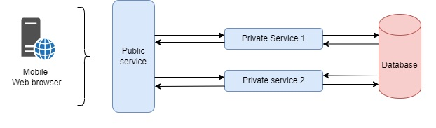

6.2. Flow Diagram

6.2.1

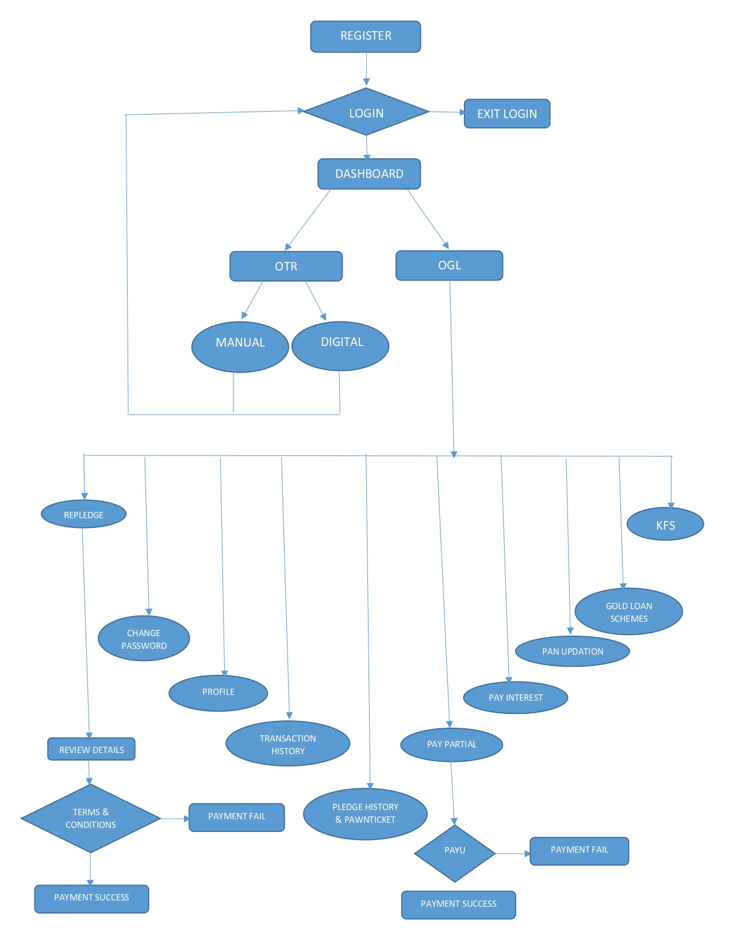

7. Screen Design and Descriptions

7.1 UI Layout Samples Dash Board

7.1 Login
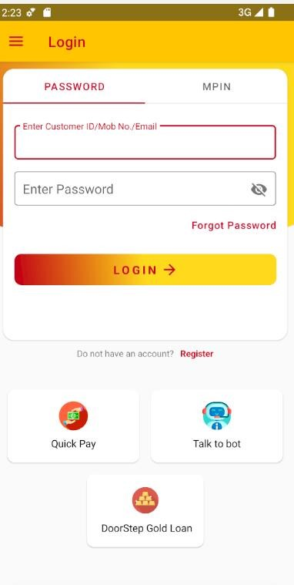

Description
It is the first screen of the application, from here the users are able to choose wheather to use login to the application using login or Mpin options. And if the user only want to pay the installment, use QuickPay which the application redirect it to a web page. If the user is a new customer, they can register account using register option. Or if the user forgot password, use forgot password option.
Name | Type | Validations
User Name | String | Required
Password | String | Required
API Used:
https://amfluat.macom.in/AsirvadGoldloan/OGLLite_MobAppService/Data_Service.asmx/mLoginEncrpt https://amfluat.macom.in/AsirvadGoldloan/OGLLite_MobAppService/Data_Service.asmx/checkOGLCustomer https://amfluat.macom.in/AsirvadGoldloan/OGLLite_MobAppService/Data_Service.asmx/GETPanStatus https://amfluat.macom.in/AsirvadGoldloan/OGLLite_MobAppService/Data_Service.asmx/GetRebateStatus
Tables Used:
TBL_ONLINE_CUSTOMER_DETAILS, tbl_online_customer_mpin
Procedures Used:
sp_ogl_queries, sp_online_queries

7.2 Register
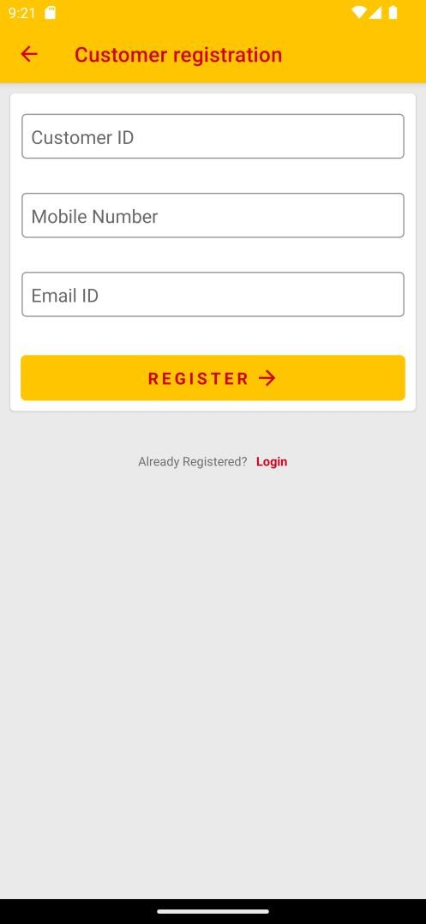

Description
If the user doesn’t have an account, they are able to register an account through this page..
Name | Type | Validations
Customer Id | String | Required
Mobile Number | String | Required
Email | String | Required
API Used:
https://amfluat.macom.in/AsirvadGoldloan/OGLLite_MobAppService/Data_Service.asmx/mSearchCustomerandSendOTP https://amfluat.macom.in/AsirvadGoldloan/OGLLite_MobAppService/Data_Service.asmx/mRegisterCustomer

Tables used:
tbl_online_login_register, tbl_online_customer_details, TBL_ONLINE_FPASSWORD_OTPLOG
Procedures Used:
sp_ogl_queries, sp_online_queries

7.3 Forgot Password
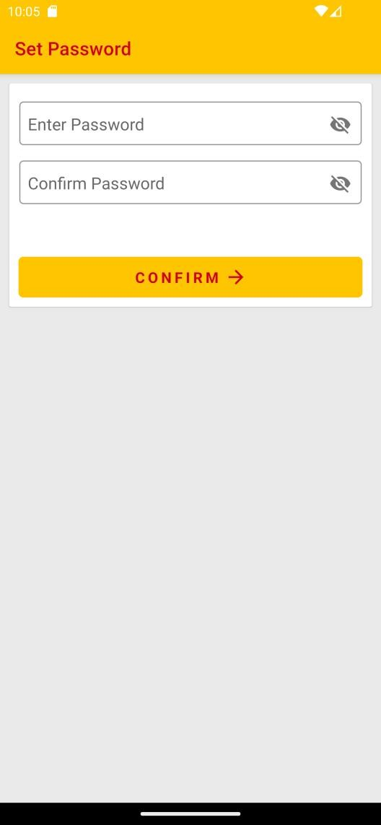

Description
If The user forgot their password, they are able to reset their password through this page.
Name | Type | Validations
Enter Password | String | Required
Confirm Password | String | Required

API Used:
https://amfluat.macom.in/AsirvadGoldloan/OGLLite_MobAppService/Data_Service.asmx/mUpdatePassword https://amfluat.macom.in/AsirvadGoldloan/OGLLite_MobAppService/Data_Service.asmx/mUpdatePassword_change
Tables Used:
tbl_online_customer_details

Procedures Used:
sp_ogl_queries, sp_online_queries

7.4 Dashboard
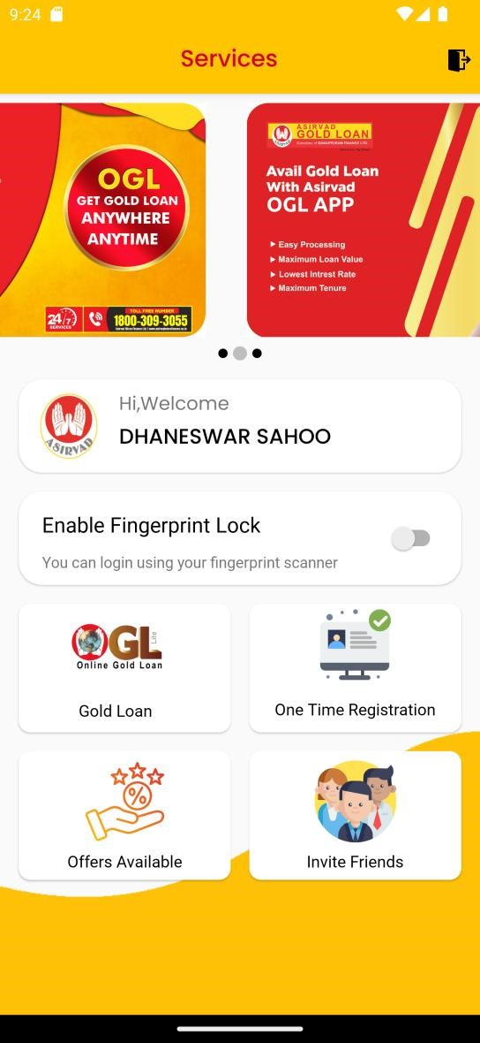

Description
Dashboard screen is the main page after the user login. From here the user have four options - Gold Loan , One Time
Registration, Offers Available, Invite Friends. And Also user can Enable the fingerprint Lock

7.5 One Time Registration
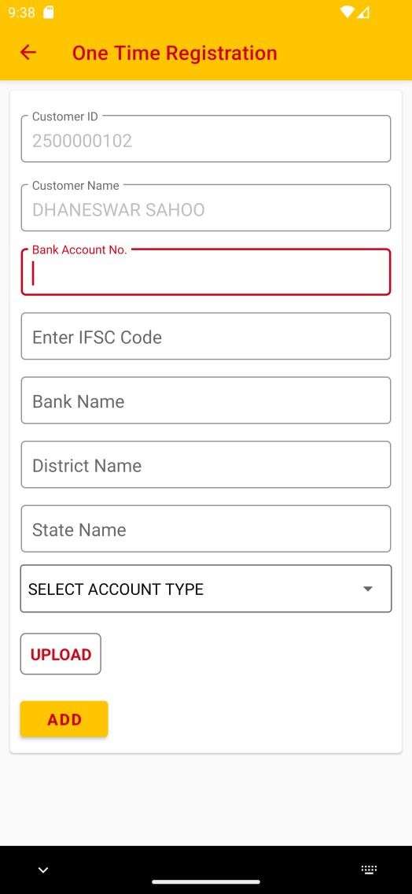

Description
Through this page, we are able to verify the user bank account for their loan disbursement.
Name | Type | Validations
Bank Account Number | String | Required
IFSC Code | String | Required
Account Type | Drow Down | Required
API Used:
https://amfluat.macom.in/AsirvadGoldloan/OGLLite_MobAppService/Data_Service.asmx/GetAccType
https://amfluat.macom.in/AsirvadGoldloan/customer_publicapi/banks/searchifsc
https://amfluat.macom.in/Asirvadgoldloan/mfpublickycapi/api/bank
https://amfluat.macom.in/AsirvadGoldloan/customer_public/api/banks/banks
https://amfluat.macom.in/AsirvadGoldloan/OGLLite_MobAppService/Data_Service.asmx/otr_customer_bank_details_submit
https://amfluat.macom.in/AsirvadGoldloan/customer_public/api/v1/customerphoto/addPhoto
https://amfluat.macom.in/AsirvadGoldloan/customer_public/api/Photo/AddBankOgl
https://amfluat.macom.in/AsirvadGoldloan/los_public/api/members/addimages
https://uatbackend.asirvad.com/AsirvadGoldloan/goldloansapi/oglapi/v1/oglapproval/verifiedcustomer

Tables used:
aml_customer.tbl_customer_bank_details , tbl_online_gl_cust_mst ,
neft_customer , customer_bank_passbook , aml_customer.TBL_CUSTOMER_IMAGES
aml_accounts.neft_customer ,ONLINE_CUSTOMER_AGREEMENT , tbl_bank_verification
Procedures Used:
sp_ogl_queries, sp_online_queries, sp_online_mobapp

7.6 OGL
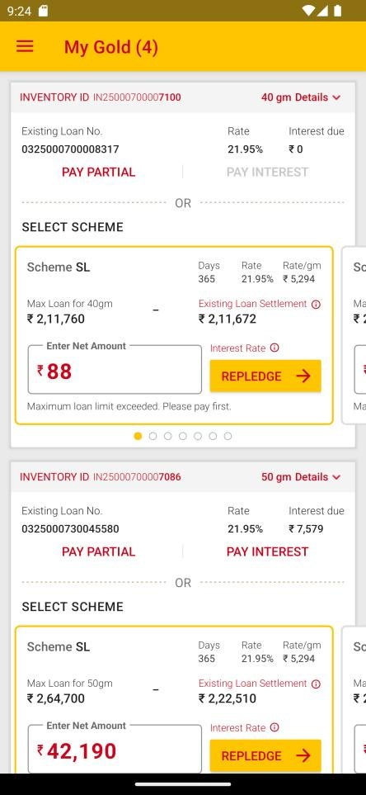

Description
The users pledges whould be listed here. From here he/she can choose to pay installments or repledge the loan.

API Used:
https://amfluat.macom.in/AsirvadGoldloan/OGLLite_MobAppService/Data_Service.asmx/GetPledeges https://amfluat.macom.in/AsirvadGoldloan/OGLLite_MobAppService/Data_Service.asmx/GetPledgeDetailsOnline https://amfluat.macom.in/AsirvadGoldloan/OGLLite_MobAppService/Data_Service.asmx/GetSchemeDetails
Tables Used:
tbl_language_rqst
Procedures Used:
sp_ogl_queries, sp_online_queries, pledge_ogl

7.7 Payment
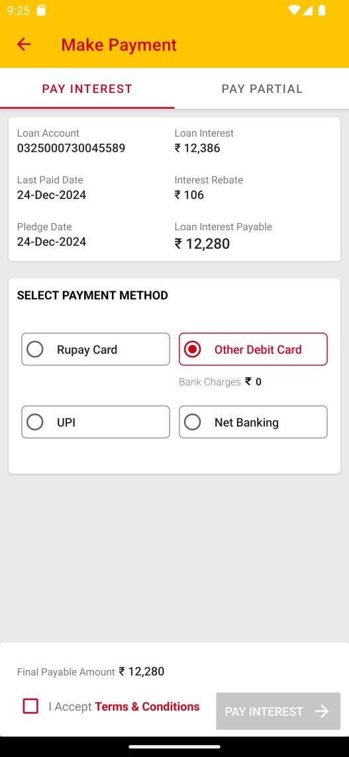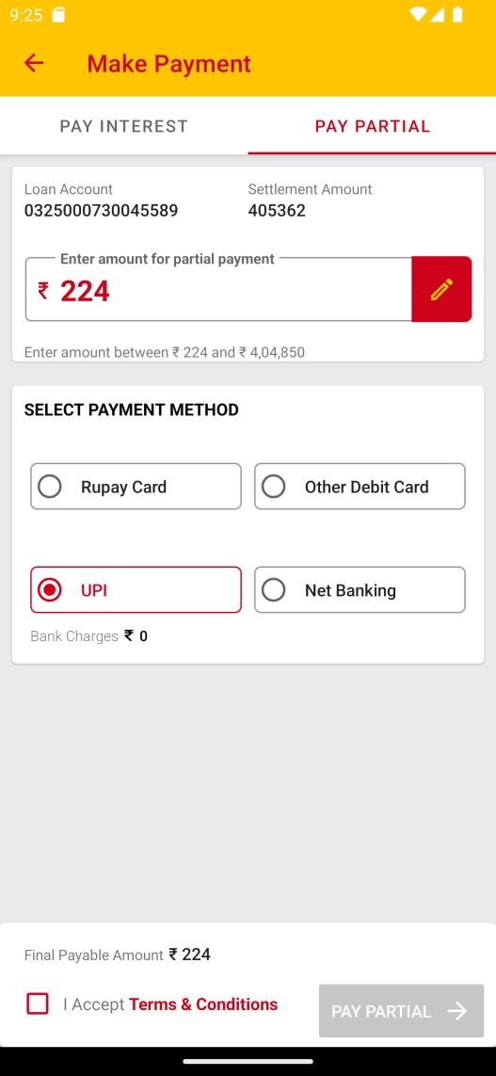

Description
The customer can complete payment through this page by choosing payment mode and entering amount. Here we are using PayU as payment gateway.
Name | Type | Validations
Amount | String | Required
API Used:
https://amfluat.macom.in/AsirvadGoldloan/OGLLite_MobAppService/Data_Service.asmx/mPledgeDetails https://amfluat.macom.in/AsirvadGoldloan/OGLLite_MobAppService/Data_Service.asmx/mLoanDetails https://amfluat.macom.in/AsirvadGoldloan/OGLLite_MobAppService/Data_Service.asmx/mGetServiceCharge https://amfluat.macom.in/AsirvadGoldloan/OGLLite_MobAppService/Data_Service.asmx/payuinputdata
Tables Used:
tbl_online_ctran_entries, tbl_online_tran_track
Procedures Used:
sp_ogl_queries, sp_online_queries, sp_online_transactions, Pledge_Closing_Entries_online

7.8 Repledge

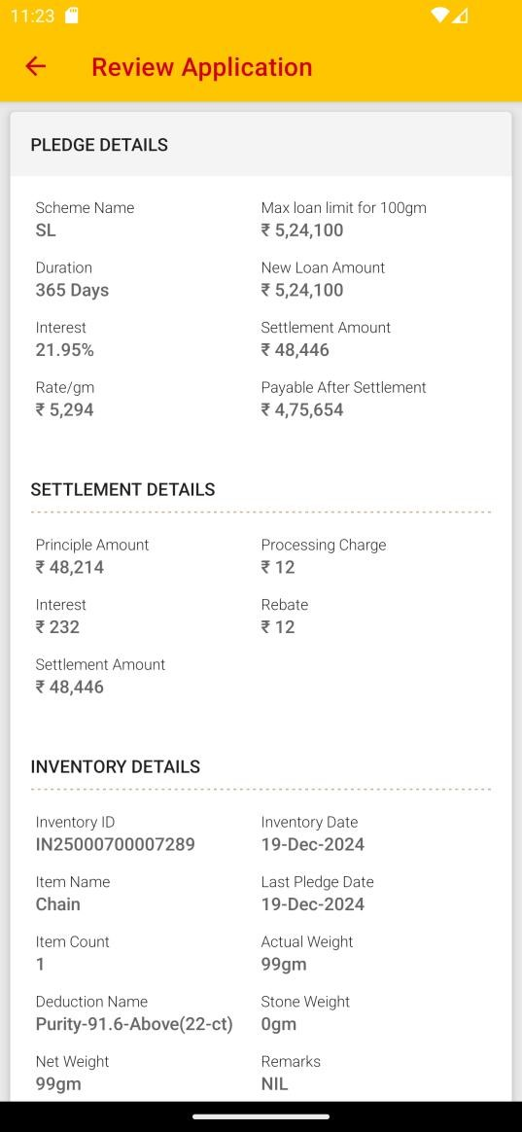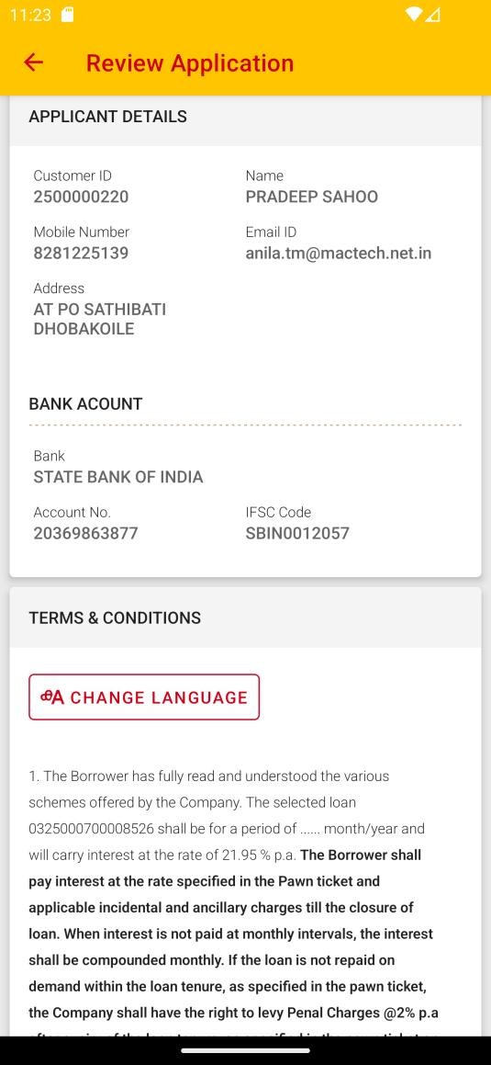

Description
The customer whould able to replede their loan through this page.
API Used:
https://uatvef.manappuram.com/Customerapp_public/api/v1/RcUpdate/RCUpdateSendOTP https://uatvef.manappuram.com/Customerapp_public/api/v1/RcUpdate/RCUpdateVerifyOTP https://uatvef.manappuram.com/Customerapp_public/api/v1/RcUpdate/RCUpdateSubmit
Customer can re pledge in any of the eligible scheme. Pledge details with interest rate, tenure, and amount will be displayed to review the details.
If the customer interested to do re pledge, then he can proceed by accepting the” terms and conditions”. OTP verification needs to confirm the repledge.
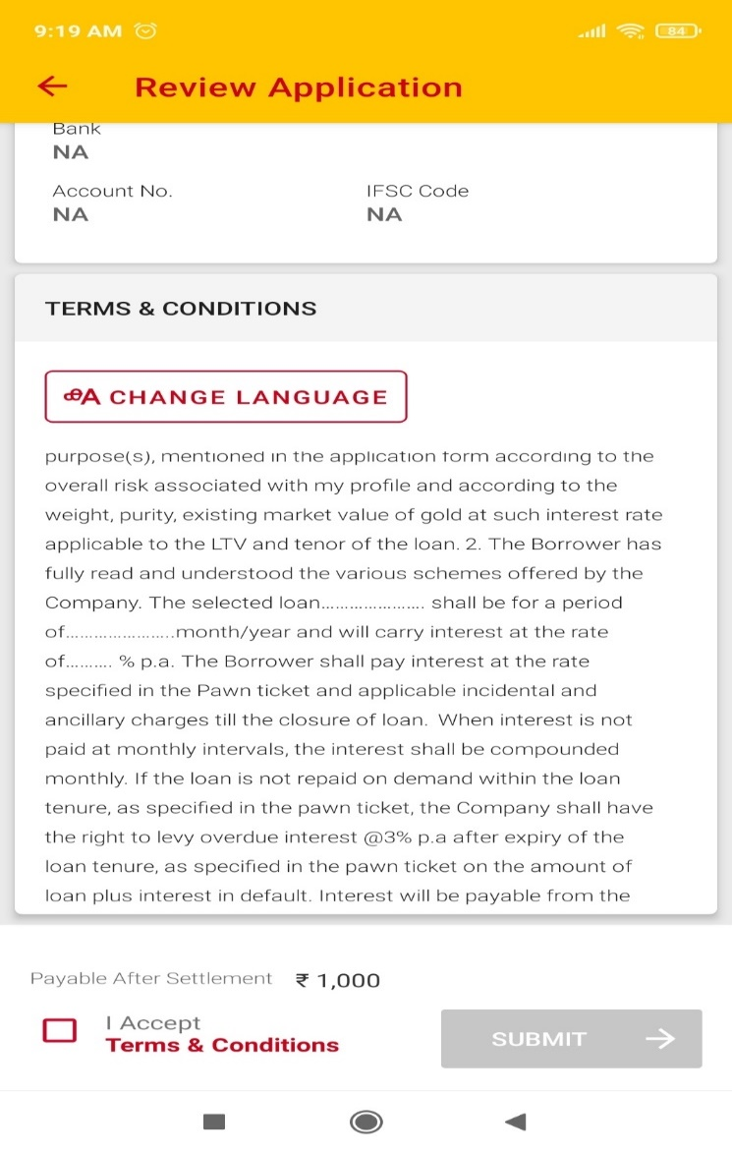
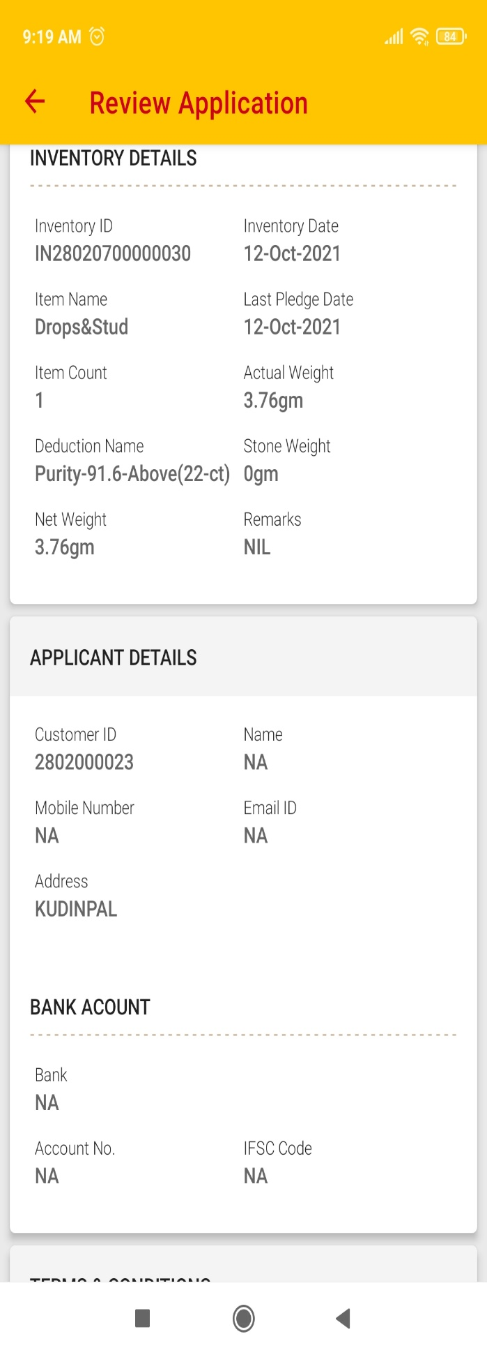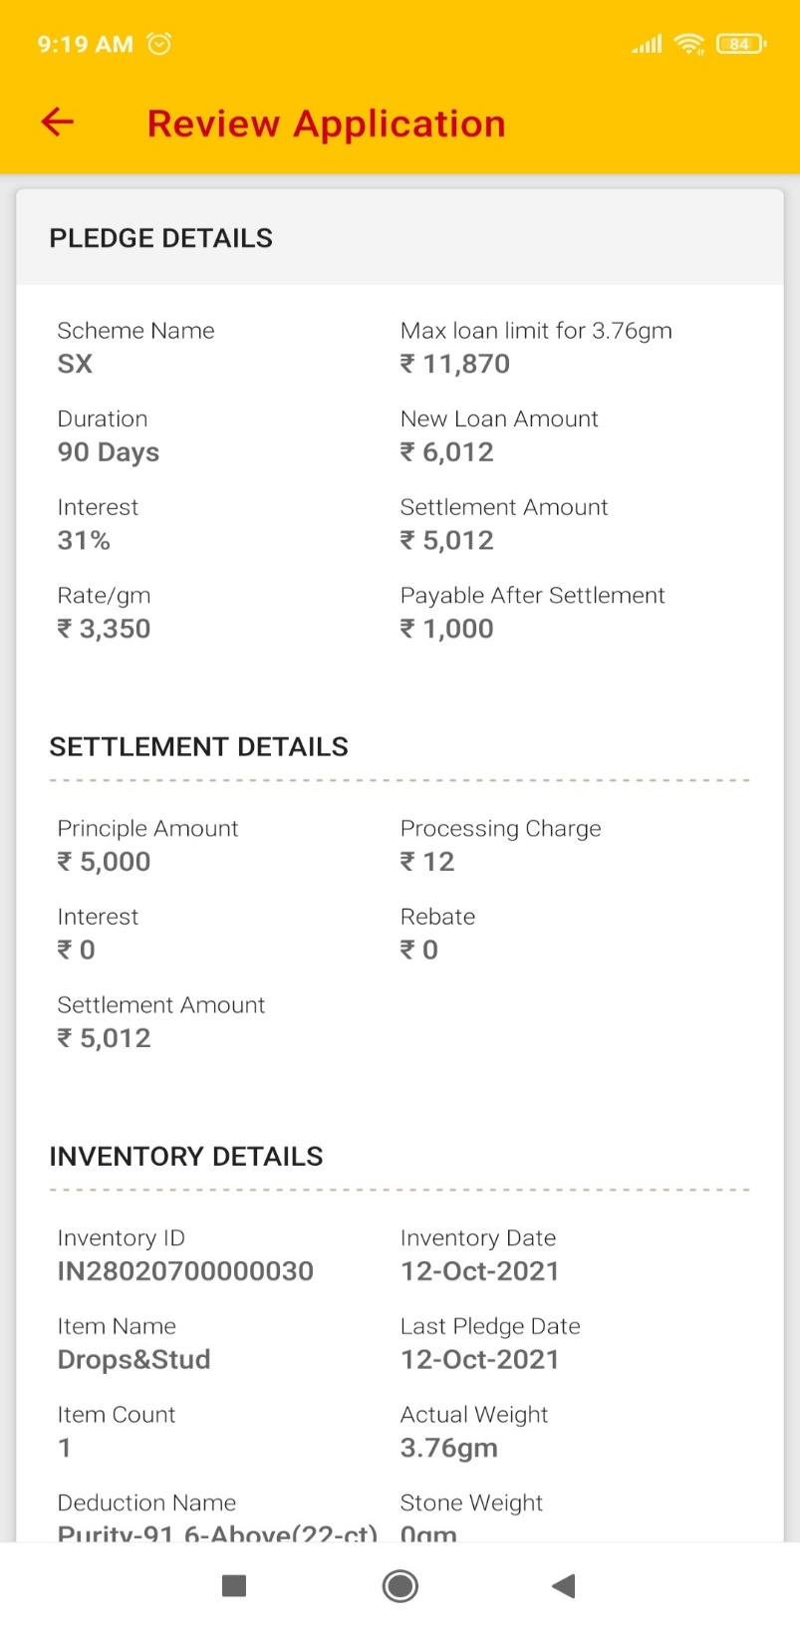
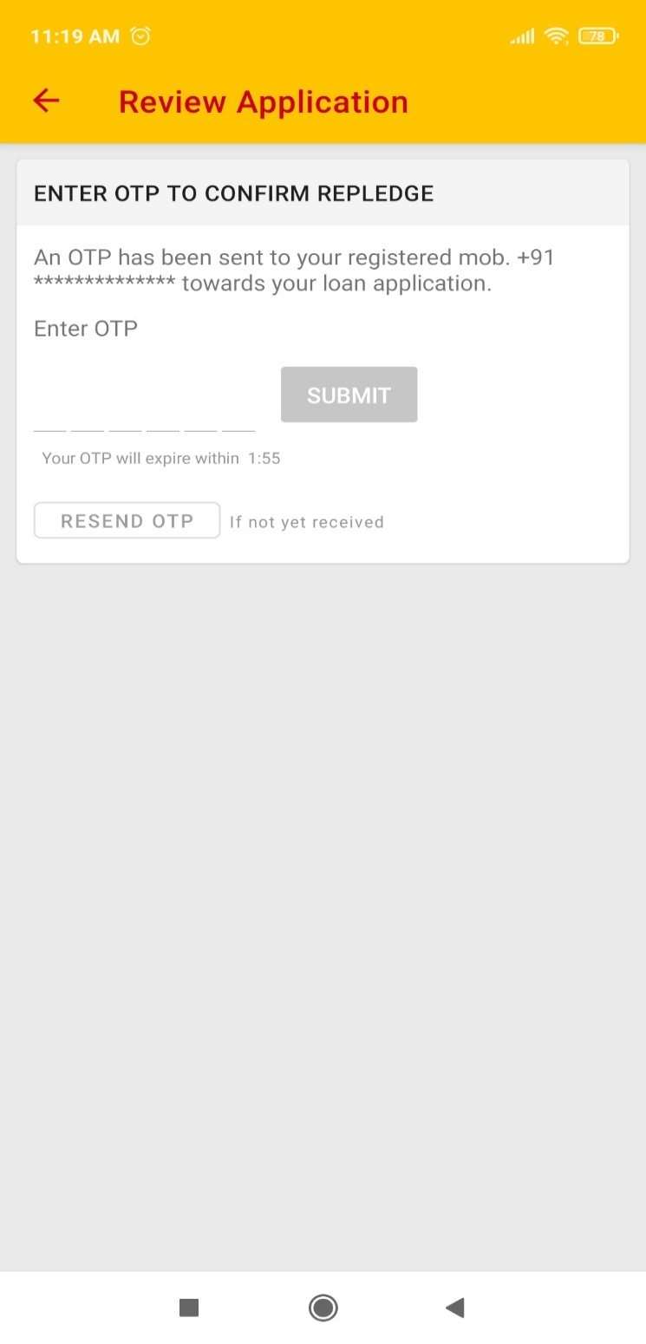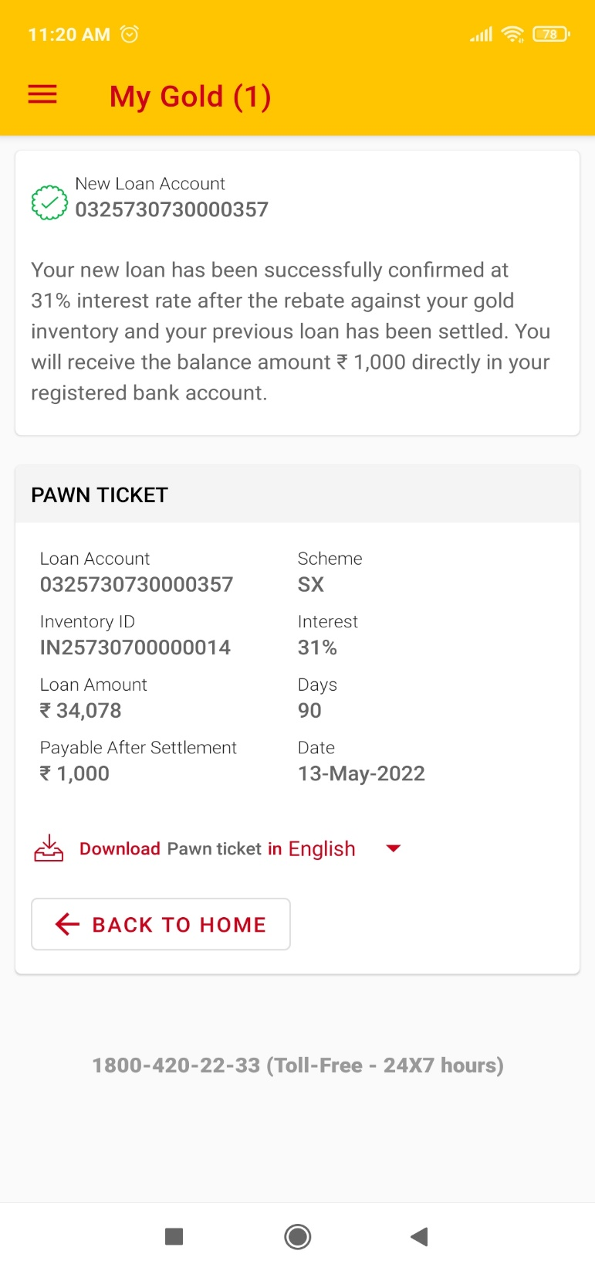

Tables Used: tbl_online_ctran_entries, tbl_online_tran_track
Procedures Used: sp_ogl_queries, sp_online_queries, sp_online_transactions, Pledge_Closing_Entries_onl_rp
IMPS disbursement time delay rectification API’S

https://lms.asirvad.com/mfpubliclmsapi/api/disbursement/ICICIDisbursement

Request:
Payment_PutRequest.typeId = 1;

Payment_PutRequest.priority = "0100";

Payment_PutRequest.custId = custid;

Payment_PutRequest.loanId = plno;

https://lms.asirvad.com/mfpubliclmsapi/api/disbursement/BOBDisbursement
Request:
Payment_PutRequest.fileId = plno;
Payment_PutRequest.customerId = custid;
Payment_PutRequest.paymentMode = "NEFT";

Response:

apiResponse.status

7.9 Profile
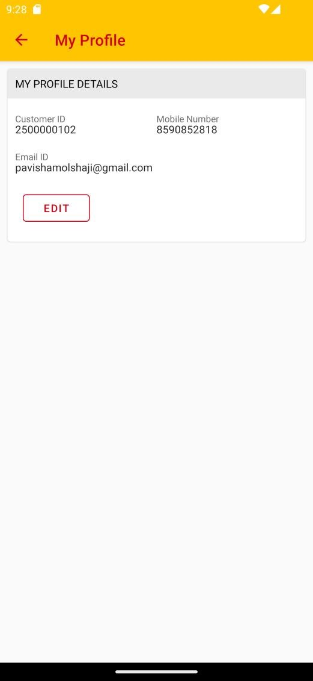

Description
The user whould able to see their personal details like customer id, customer name, mobile number, email id. And from here they are able to modify their mail id and mobile number.
API Used:
https://amfluat.macom.in/AsirvadGoldloan/OGLLite_MobAppService/Data_Service.asmx/mCustomerProfile

7.10 OGL History
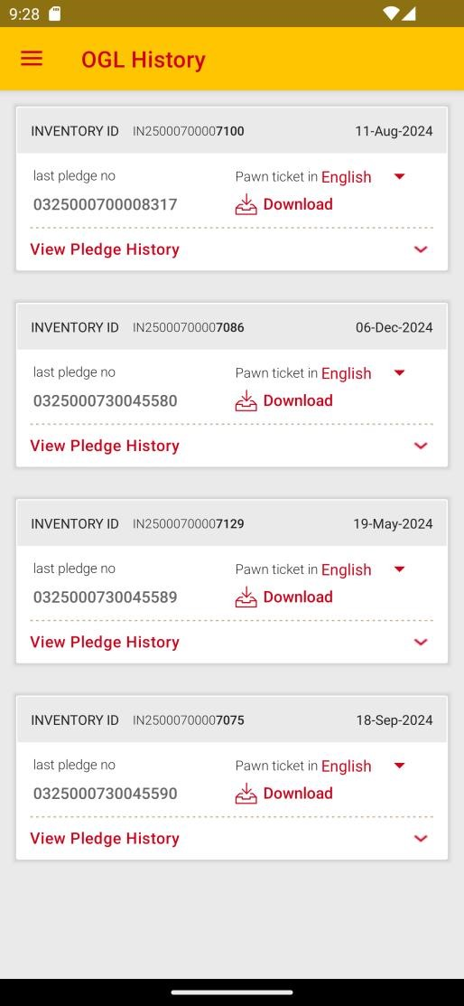

Description
Show their OGL history. Also able to download their pawn ticket through this page.
API Used:
https://amfluat.macom.in/AsirvadGoldloan/OGLLite_MobAppService/Data_Service.asmx/GetPledeges https://amfluat.macom.in/AsirvadGoldloan/OGLLite_MobAppService/Data_Service.asmx/GetOglHistory https://amfluat.macom.in/AsirvadGoldloan/OGLLite_MobAppService/Data_Service.asmx/GetPawnTicketb

7.11 Transaction History
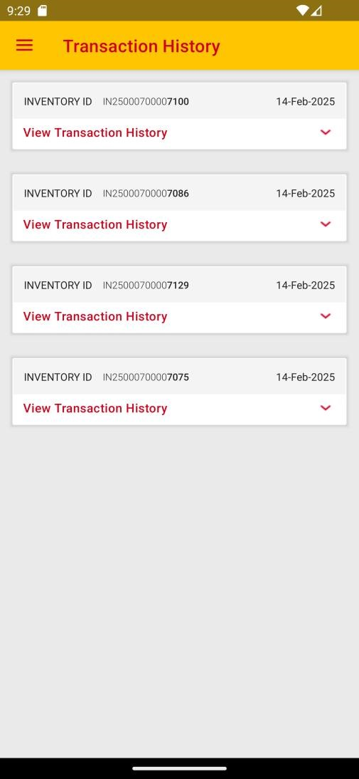

Description
Show the users payment history.
API Used:
https://amfluat.macom.in/AsirvadGoldloan/OGLLite_MobAppService/Data_Service.asmx/GetPledeges
https://amfluat.macom.in/AsirvadGoldloan/OGLLite_MobAppService/Data_Service.asmx/GetOnlpaymentHistory

7.12 Change Language
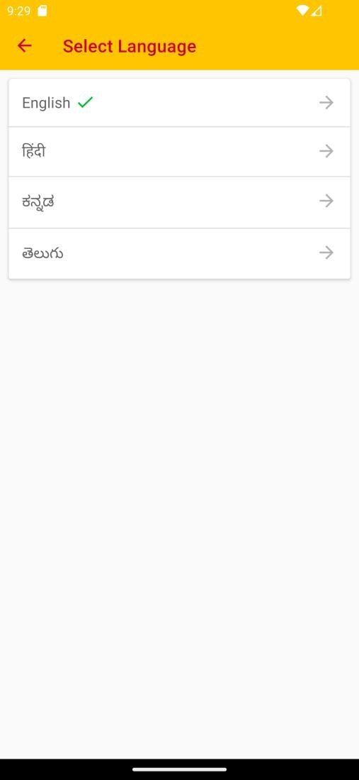

Description
The Asirvad OGL Lite application support multiple language through out the application. The user able to change language through this page.

7.13 Change Password
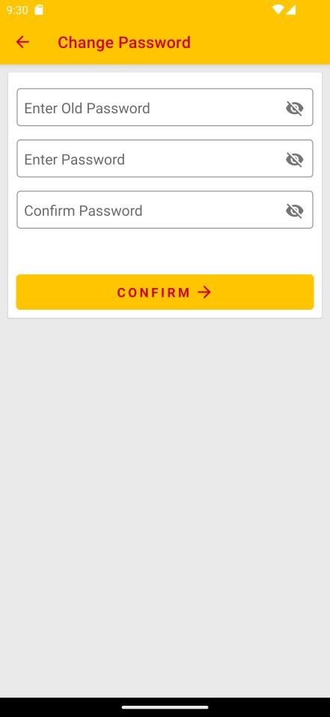

Description
User able to change their password using this page.
Name | Type | Validations
Enter Old Password | String | Required
Enter Password | String | Required
Confirm Password | String | Required
API Used:
https://amfluat.macom.in/AsirvadGoldloan/OGLLite_MobAppService/Data_Service.asmx/mUpdatePassword https://amfluat.macom.in/AsirvadGoldloan/OGLLite_MobAppService/Data_Service.asmx/mUpdatePassword_change
Tables Used: Tbl_Online_Customer_Details
Procedures Used: sp_ogl_queries,sp_online_queries

7.14 Loan Calculator
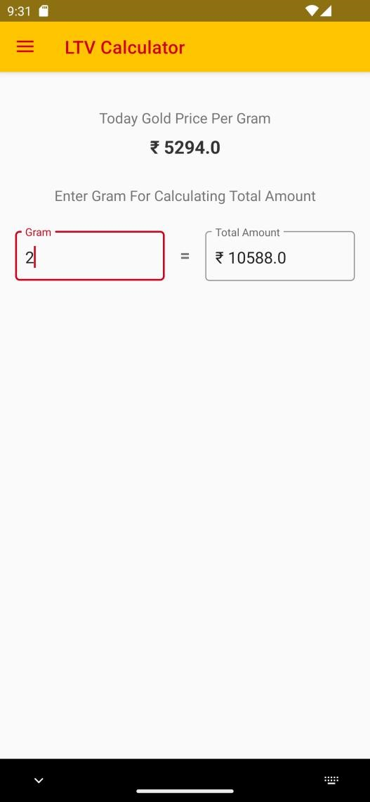

Description
Here the user able to calculate how much amount they get by entering gold quantity.
Name | Type | Validations
Gram | String | Required
API Used:
https://amfluat.macom.in/AsirvadGoldloan/OGLLite_MobAppService/Data_Service.asmx/ogl_Daily_ltv
TABLE Used: aml_gloan.pledge_scheme
Procedure Used: sp_online_queries

7.15 KFS Download
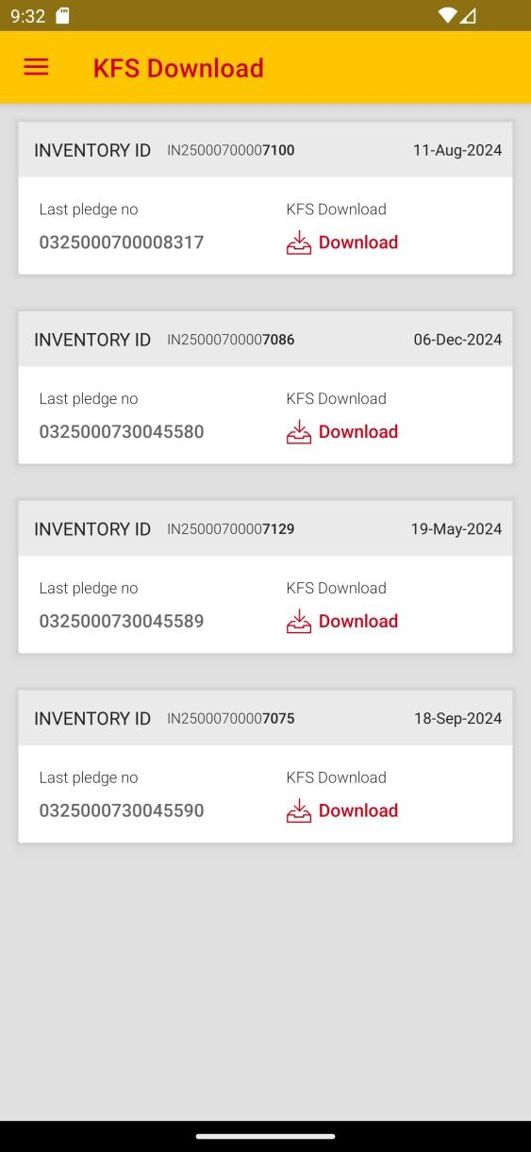

Description
Through here the user able to download their each pldges key factor sheet.
API Used:
https://amfluat.macom.in/AsirvadGoldloan/OGLLite_MobAppService/Data_Service.asmx/GetPledeges https://amfluat.macom.in/AsirvadGoldloan/OGLLite_MobAppService/Data_Service.asmx/SendOtpKfs https://amfluat.macom.in/AsirvadGoldloan/OGLLite_MobAppService/Data_Service.asmx/verifyOTPforkfs
Procedure Used:
Sp_online_queries
Table Used:
pledge_quot, pledge_scheme , branch_detail_new ,pledge_master, general_parameter

7.16 Opt Out
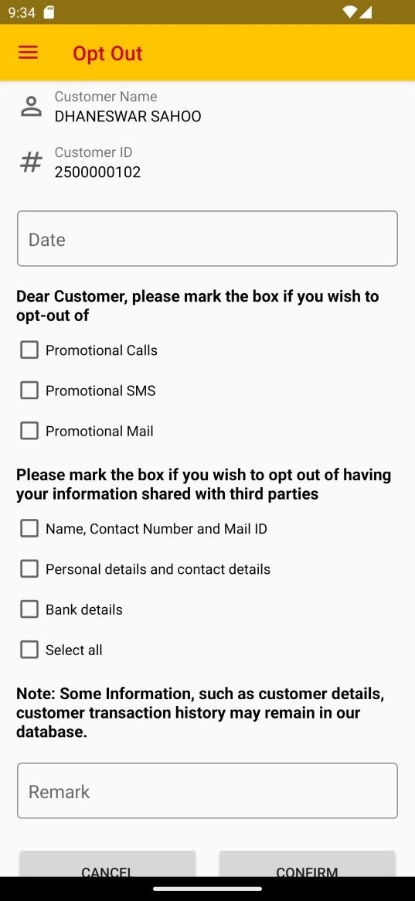

Description
Using this page the user can opt out their loans.
Name | Type | Validations
Date | String | Required
Remark | String | Required
API Used:
https://amfluat.macom.in/AsirvadGoldloan/OGLLite_MobAppService/Data_Service.asmx/opted_customer https://amfluat.macom.in/AsirvadGoldloan/OGLLite_MobAppService/Data_Service.asmx/add_opt_option
Procedure Used:
Sp_online_queries
Table Used:
TBL_OGL_OPT_OPTION_CUST

7.7 summary of loan and Earned interest Rebate

- When clicking the Gold Loan in OGL need to show summary of loan and Earned interest Rebate

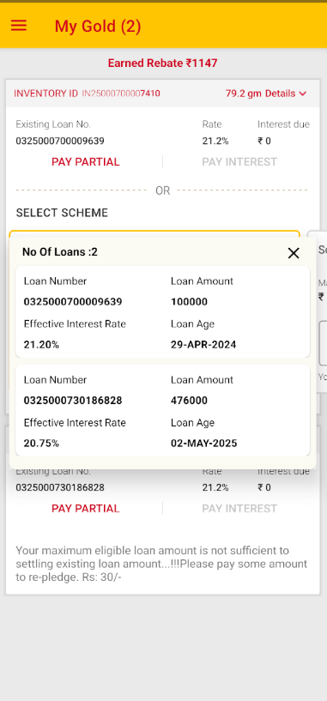

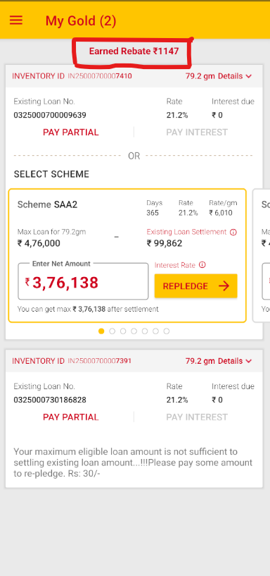

- In pay partial need to split interest amount and principle amount as shown below.

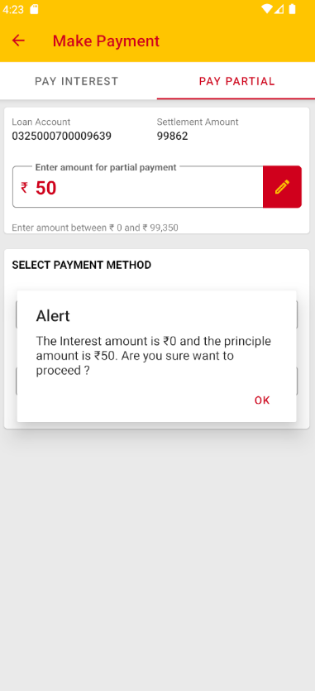

AUCTION CHARGES CHANGED
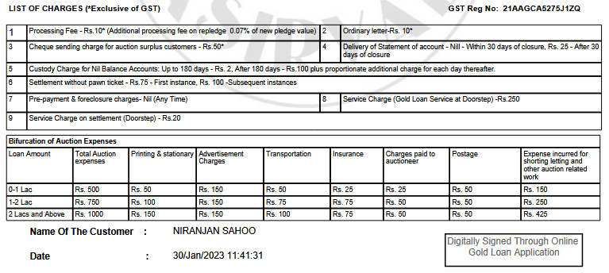

7.17 UPI PENNY DROP SYSTEM

- Customers open our OGL-Application and click to once-time-registration. At a time, UPI Intent Flow is working and displays all UPI-Support-Applications in their Mobile. Like: Google pay, Phone pe, Paytm, Bank application, etc..

- Customers click the concern UPI application and simply initiate Rs. 1/- UPI payment and get account number, IFSC, account holder's name and VPA (Virtual Payment Address)address in the response.(The debited 1 rupee is automatically refunded to the customer’s bank account with in 3 banks working days)

- Once completed the Transaction, the System will Crosscheck with Customer Name and Bank Account Name, is it matching, and the System is auto approving.

Procedure Used:

Sp_online_queries

Table used:

CUSTOMER_BANK_PASSBOOK

customer_bank_passbook_his

TBL_ADD_NEFT_CUSTOMER

aml_customer.tbl_customer_images

aml_accounts.NEFT_CUSTOMER

tbl_online_gl_cust_mst

aml_customer.tbl_customer_bank_details

aml_customer.tbl_customer

Tbl_online_customer_details

TBL_OGL_PENNYDROP_CUSTOMER_DTL –-Name match table

API Used:

https://amfluat.asirvad.com/AsirvadGoldloan/OGLLite_MobAppService/Data_Service.asmx/CustomerName_Check

https://amfluat.asirvad.com/AsirvadGoldloan/OGLLite_MobAppService/Data_Service.asmx/OnetimesendOTP

https://amfluat.asirvad.com/AsirvadGoldloan/OGLLite_MobAppService/Data_Service.asmx/OnetimeOTPVerification

https://amfluat.macom.in/Asirvadgoldloan/mfpublickycapi/api/bank

https://amfluat.macom.in/AsirvadGoldloan/customer_public/api/banks/banks

https://amfluat.macom.in/AsirvadGoldloan/customer_public/api/Photo/AddBankOgl

https://amfluat.macom.in/AsirvadGoldloan/OGLLite_MobAppService/Data_Service.asmx/otr_customer_bank_details_submit

https://amfluat.macom.in/AsirvadGoldloan/OGLLite_MobAppService/Data_Service.asmx?op=Bank_Verification_BH

https://amfluat.macom.in/AsirvadGoldloan/OGLLite_MobAppService/Data_Service.asmx/penny_customer_bank_details_submit

SCREENSHOTS:
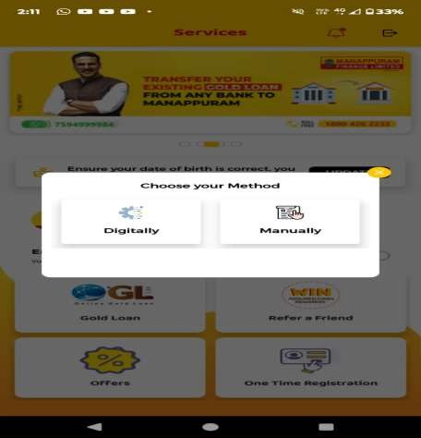
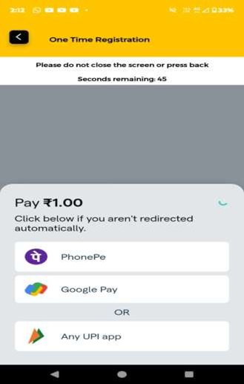
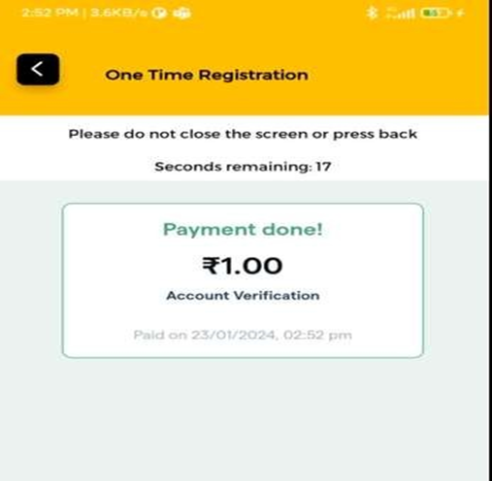

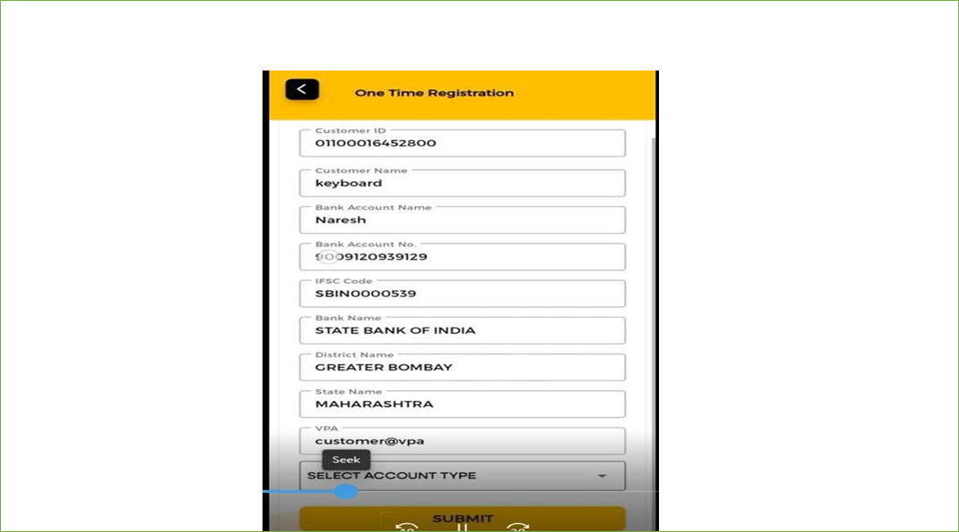

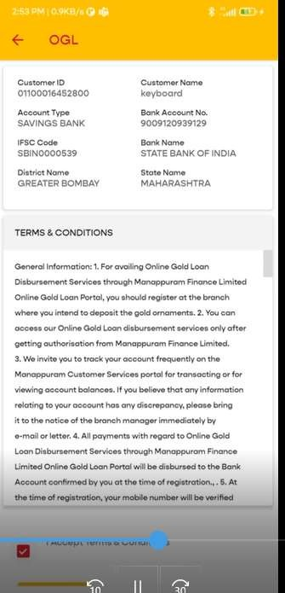

7.18 DIGITAL LENDING GUIDELINES FOR OGL APPLICATION

At present, the KFS and pawn ticket are sent to borrowers mail seperately. To ensure compliance, please ensure the following documents are automatically sent to the borrower's email address upon execution of OGL/web page repledge transactions through single mail.
“3 attachment need to attach this mail is mentioned below”(this point no need to add in mail)
1.RepledgeKFS.pdf
2.pawnticket.pdf
3.statement of account.pdf

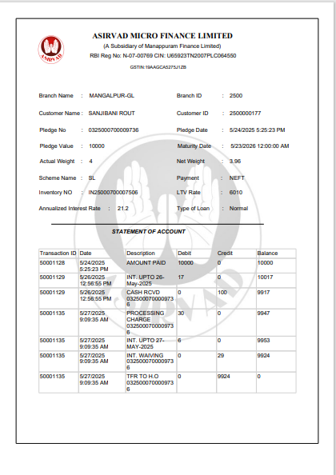
mail format below
Mail Subject: KFS Against New Pledge – 0110960730040281
Dear Customer,
This is your Key Fact Statements (KFS) details for pledge No:0110960730040281.
DO NOT SHARE WITH ANY ONE
For downloading Loan sanction letter/ Pawn ticket | visit our OGL application and download Pawn Ticket
For privacy policy | Click here

Warm Regards
Asirvad Micro Finance Limited

If you do not wish to receive such e-mail communication in the future, Click here

“After click here above. Below message need to show unsubscribed and need to save our database and future this mail only(OGL repledge/webpage mail only) need to stop for that unsubscribed customer.”
Privacy policy (direct link of PDF document.

Tables used:
TBL_OGL_REPLEDGE_MAIL_OPT t
Tbl_ogl_consolidated_mail

Procedure used:
Sp_online_queries
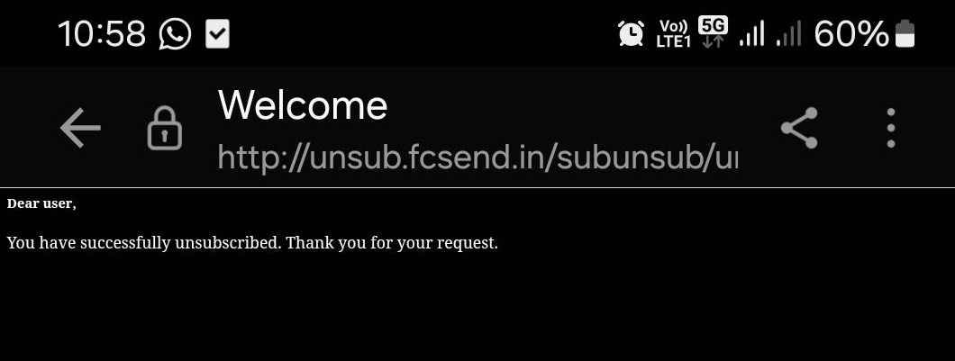

7.19 Full Settlement (OGL APP)
After approve from AH/RM using OGL APP customer complete full settlement for the corresponding pledge.
• User Login
Log in to the application using valid credentials.
Login Credentials:
2500000177
Soft@1234
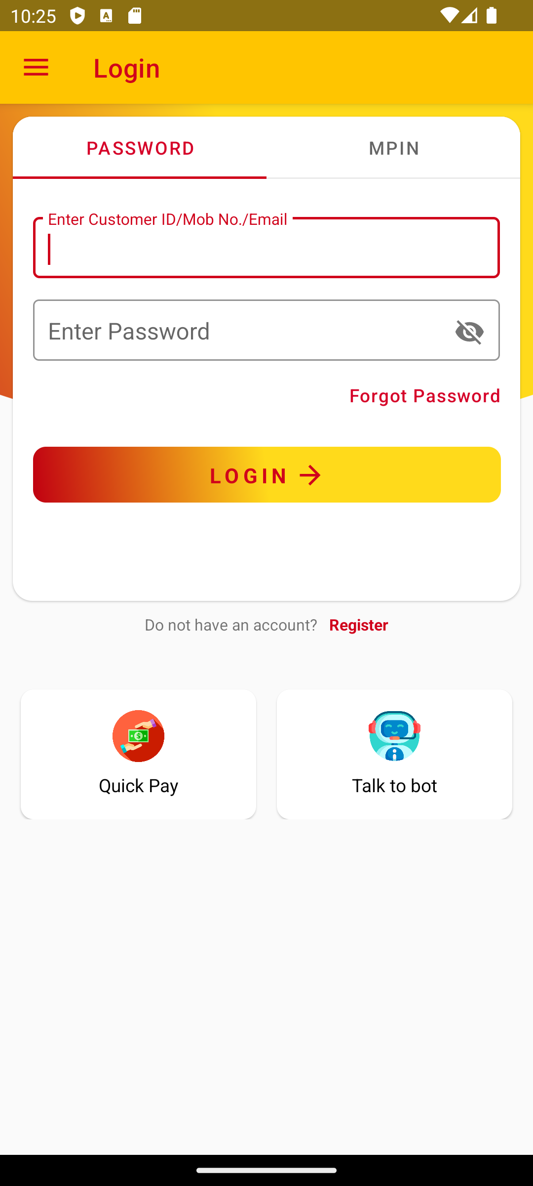
• Accessing Pay Full Option
Navigate to the Online Gold Loan (OGL) section. A new Pay Full option will be displayed alongside each eligible pledge.
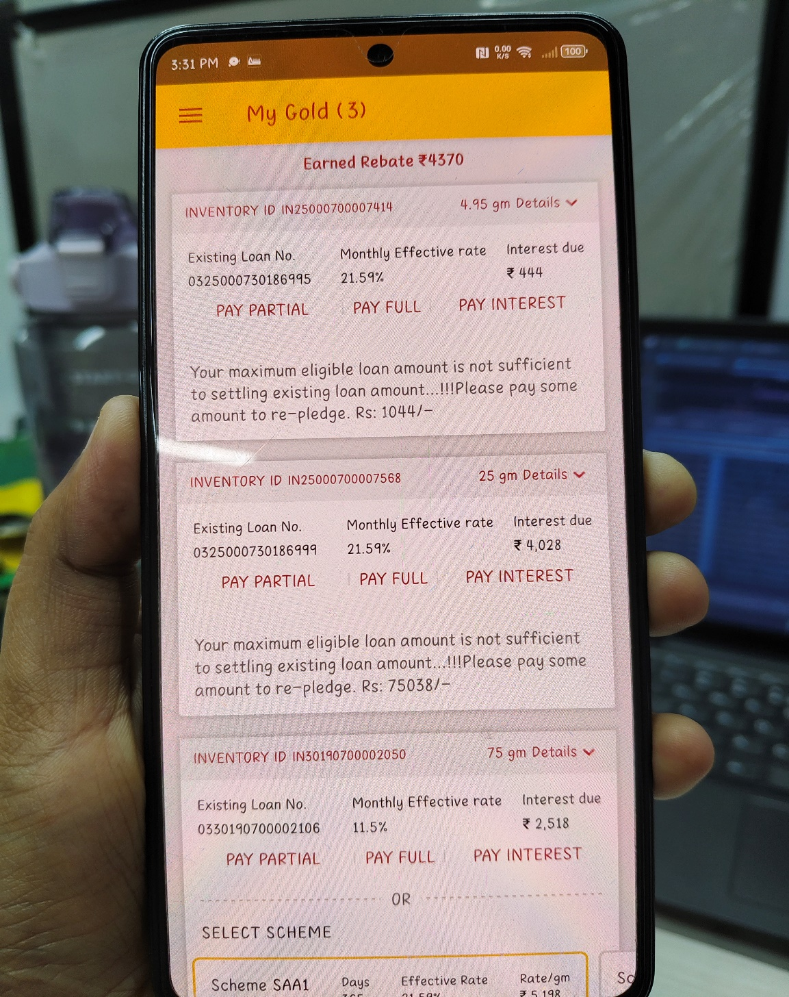
• Initiating Pay Full Process
When the user clicks the Pay Full button:
- The system triggers API calls to verify approval status and pledge validity.
- If both checks return success, the user is redirected to the Full Payment page.
• Displaying Pledge Details
On the Full Payment page, the following details are shown:
- Full settlement amount
- Applicable rebate
- Processing charges
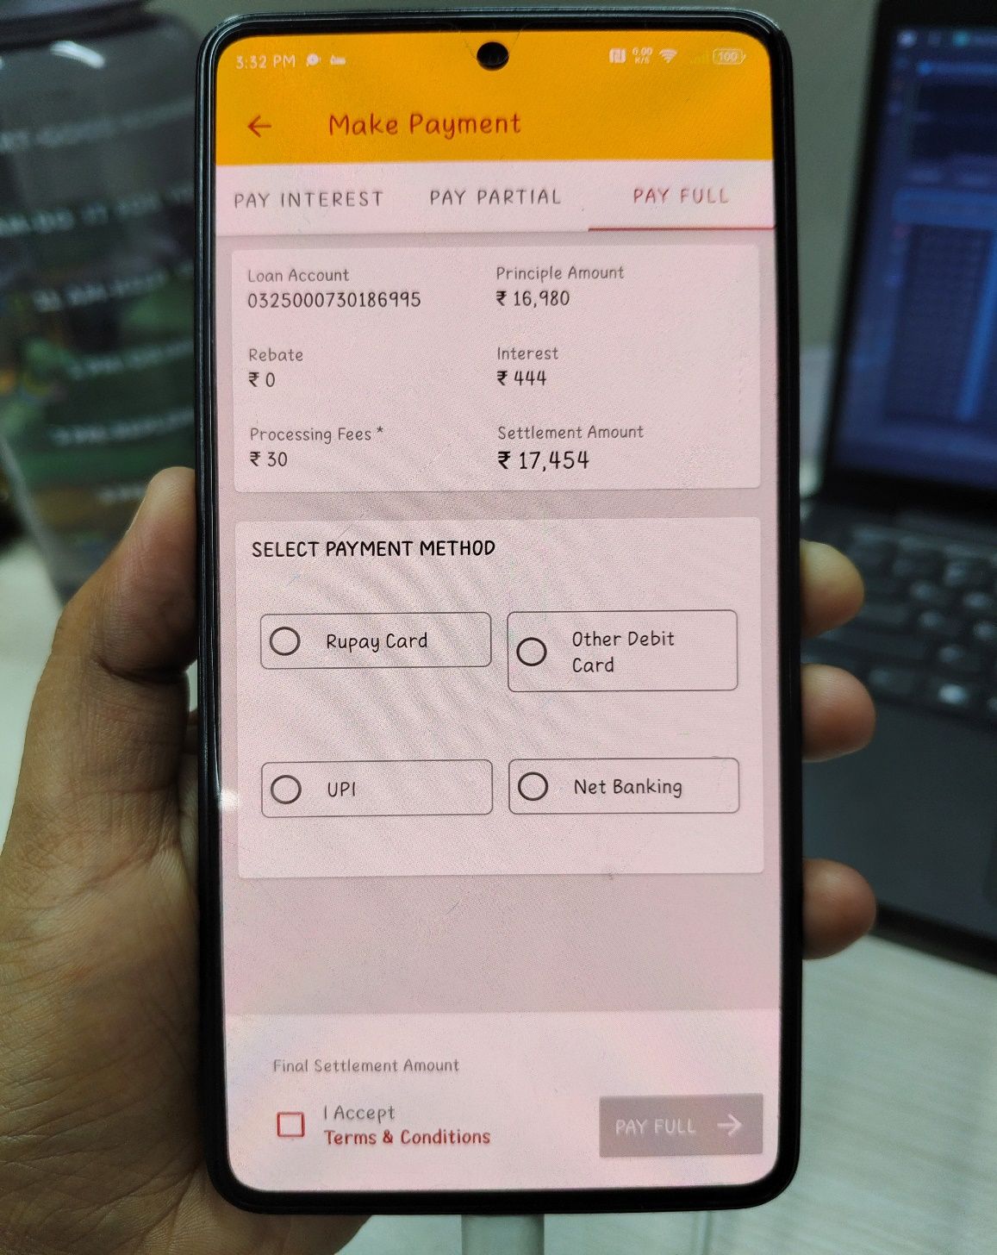
• Selecting Payment Method
The user selects a preferred payment method from the available options.
• Service Charge Calculation
Based on the selected payment method, the system calculates the applicable service charge.
• Terms & Confirmation
The user must:
- Accept the Terms and Conditions
- Click Confirm to proceed
• Completing the Payment
The payment is processed through the selected gateway.
• Post-Payment Redirection
Upon successful payment:
- The user is redirected to the Home Page
- The pledge for which payment was completed is no longer listed under pending pledges
Database Entities
Tables:
aml_gloan.cus_tran
aml_gloan.transaction_detail
aml_accounts.subsidary_transaction
aml_gloan.Tbl_online_ctran_entries (col_pay_mode= 2 and col_status=2)
aml_gloan.pledge_status (Full Settlemnt status=9 and close_dt = sysdate)
aml_gloan.tbl_online_customer_details (For customer registration and login OGL App)

Stored procedure:
Sp_online_queries
Sp_online_transactions

**Should check inventory closed after fullsettlemnt

7.20 COLENDING SCHEME PAYMENT THROUGH OGL

In OGL Colending schemes cannot proceed with repledge. But can repay to the pledge and
Minimum amount to pay is set to up to date interest.

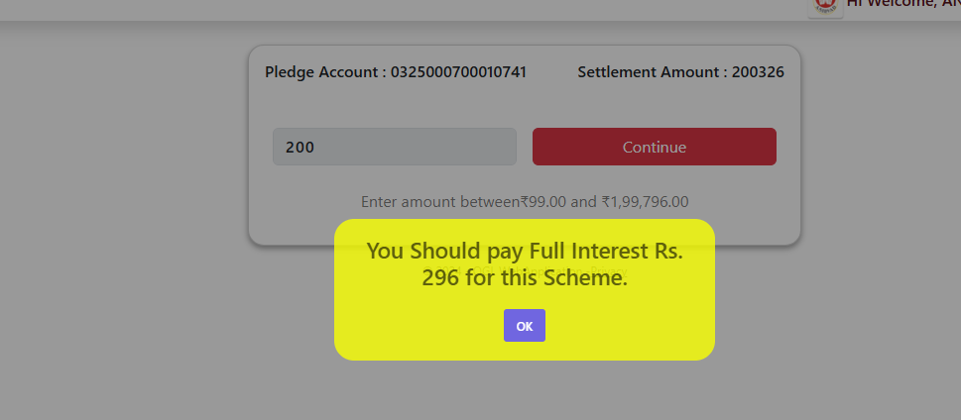

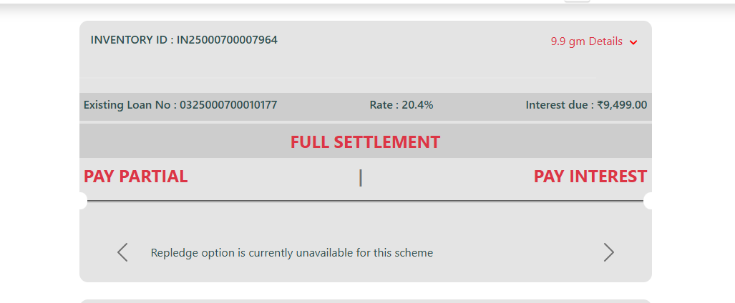

Stored procedure:

PLEDGE_CLOSING_ONLINE_COLENDING

Tables:
TBL_COLENDING_INTEREST
tbl_colending_pledge_master

Api Used:

https://appsbackend.asirvad.com/asirvadgoldloan/oglwebapi/Getcolending_pay

7.21 Retention and Backup of Gold Loan Digital Documents
(mongodb)

This CRF pertains to the report on issue related to retention and backup of Online Gold Loan (OGL) documents. As a financial institution, it is imperative that all critical digital documents are securely stored and readily retrievable for a minimum period of eight years.
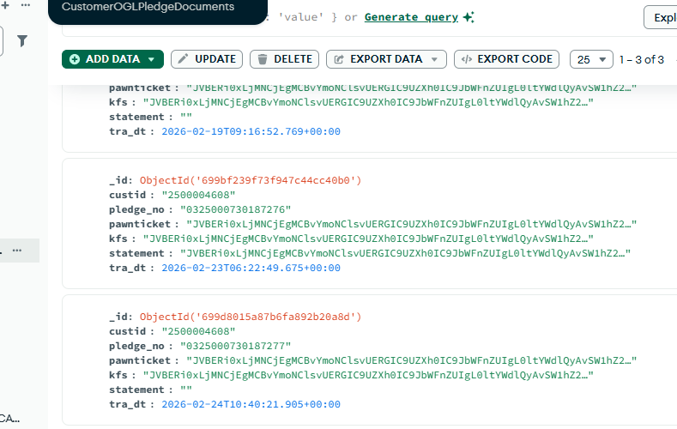

API Used:
If New repledge done the documents added to the DB
https://uatbackend.asirvad.com/AsirvadGoldloan/OglWebApi/MongoInsertDoc

If an existing pledge document try to download system will check already inserted then existing doc from mongo db will generate other wise new created.

https://uatbackend.asirvad.com/AsirvadGoldloan/OglWebApi/getMongoDoc
https://uatbackend.asirvad.com/AsirvadGoldloan/OglWebApi/MongoUpdateDoc

Procedure :
Sp_online_queries

Log Table:
TBL_OGL_DOCS_MONGO_REF

7.22 UPI reverse Penny drop modify
This proposal outlines the enhancement of the OGL App dashboard to include a Bank Account Modification facility, aligned with the parent company’s requirements. Currently, the app supports UPI Reverse Penny Drop and one-time bank account registration. However, customers who have already registered do not see an option to modify their bank details digitally. The proposed change ensures that registered users can view their existing bank account information and securely update it through UPI reverse authentication. Once a successful modification is completed, the option will be disabled for that customer, maintaining a one-time modification policy. This initiative improves transparency, customer convenience, and compliance with organizational standards.

- Add One-Time Registration
Customers must first complete initial bank account registration.

  - Register bank account details once
  - UPI Reverse Penny Drop validates account

- Show Modification Option
After registration, dashboard displays 'Bank Account Modification'.

  - Visible only for registered customers
  - Not shown for unregistered or incomplete registration
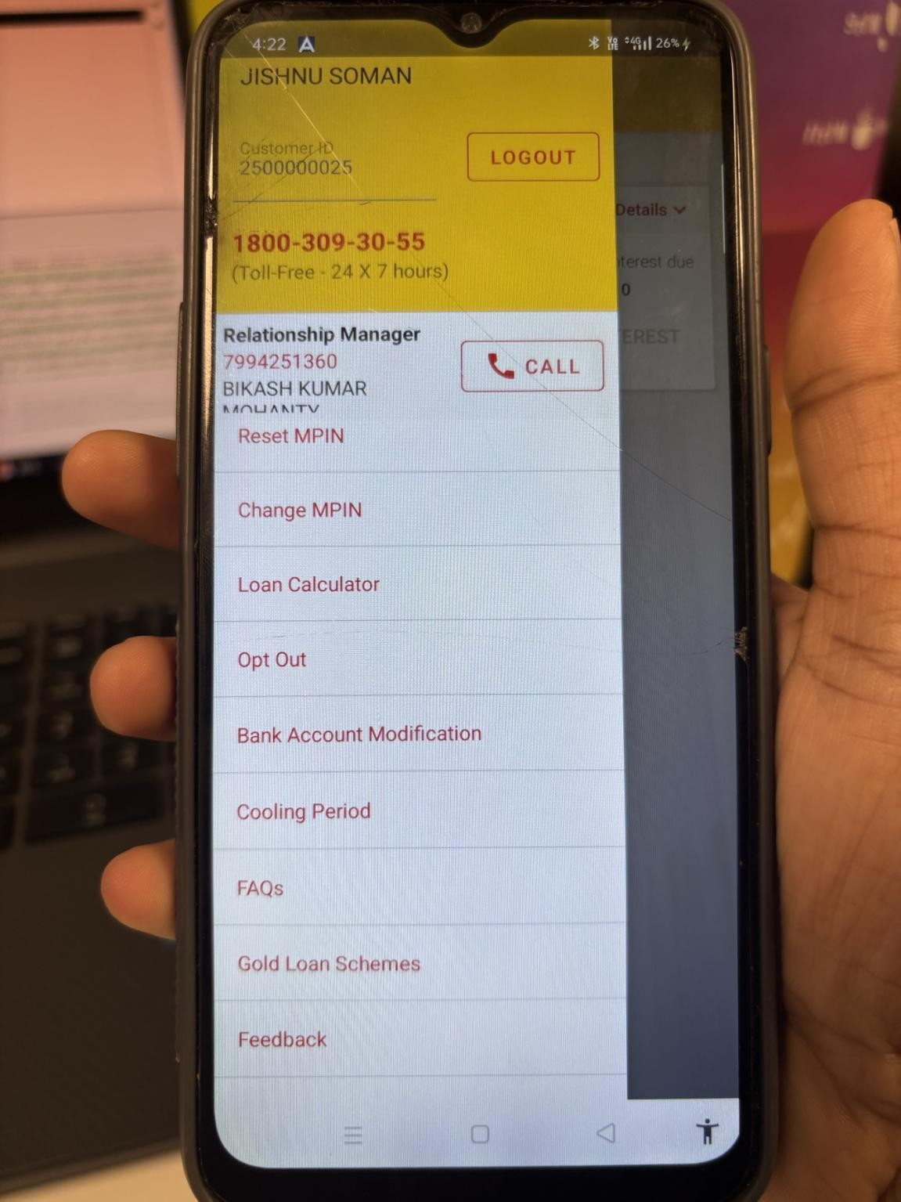

- Display Existing Details
When clicked, app shows current bank account info.

  - IFSC code
  - Account numberButtons: Cancel or Proceed to Modify
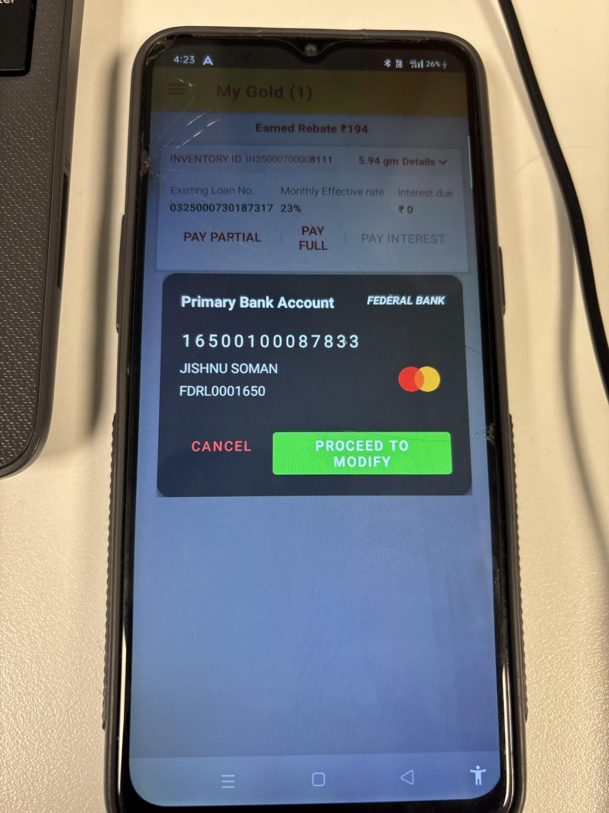

- Proceed to Modify
Customer initiates digital modification via UPI reverse.
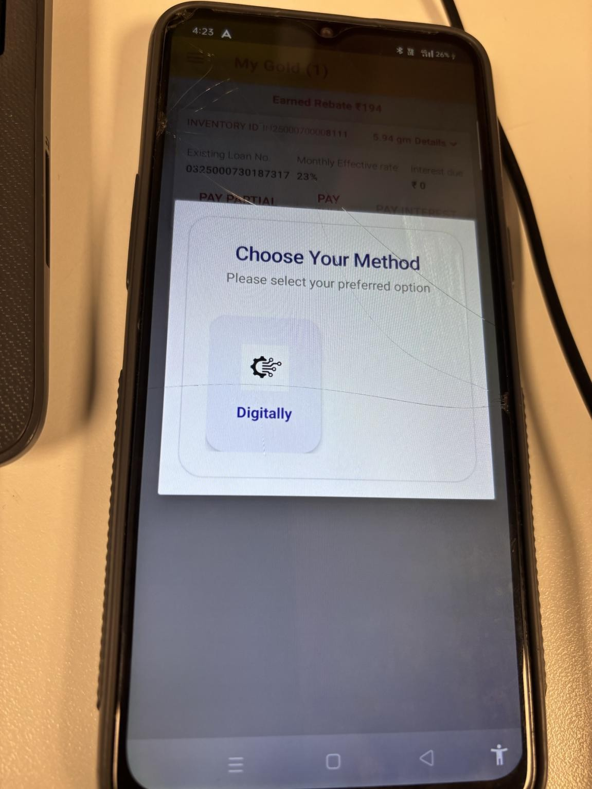

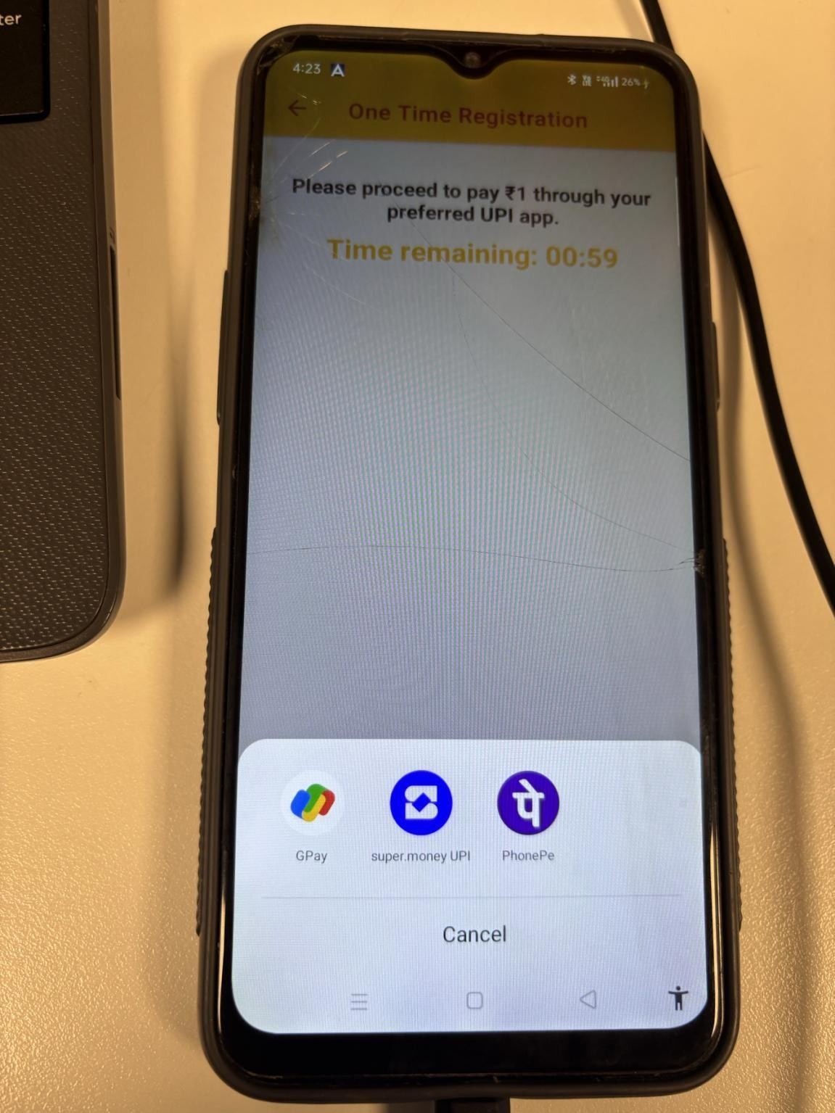

Tables and procedures used

Sp_online_queries
AML_CUSTOMER.TBL_CUSTOMER_BANK_DETAILS TBL_OGL_PENNYCUST_UPDATE_DTL

7.23 stamp duty amount, and the Payable After Settlement
1. During the OGL repledge process, the review application under Pledge Details should displ ay
the stamp duty amount, and the Payable After Settlement field should reflect the amount after deduction of stamp duty.
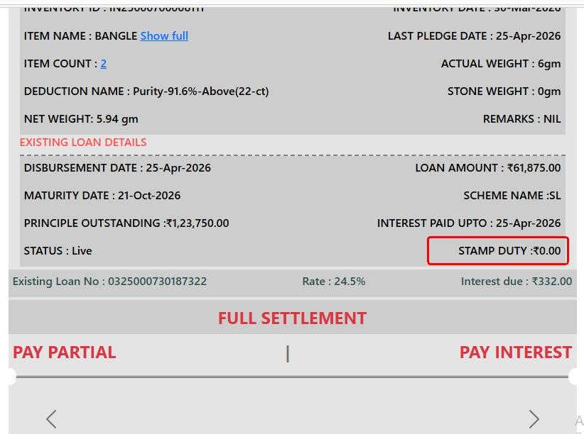

3. After the OGL repledge is completed, the Success Page should display the stamp duty amount and the Payable after Settlement amount after deduction of stamp duty. The excess amount credited to the registered bank account should also be shown after deduction of stamp duty.
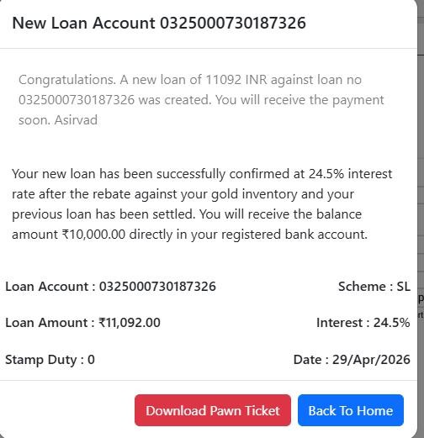

When a customer whose annual household income is below Rs.3.25 lakh initiates any transaction, the
system should display the following Alert message:
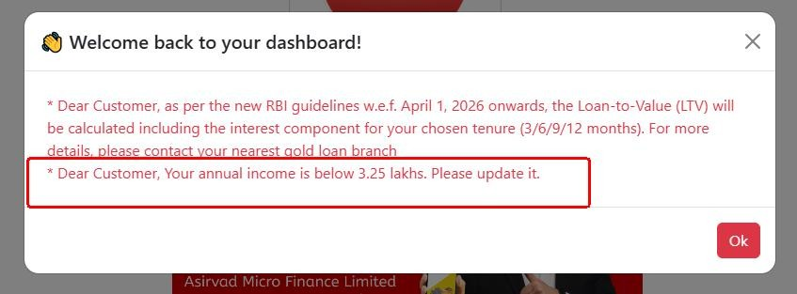

The statement account menu in dashboard in the name of “Account Statement”.
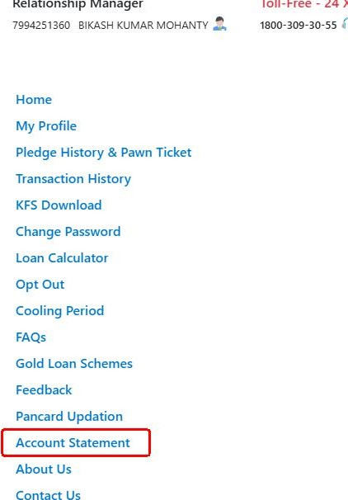

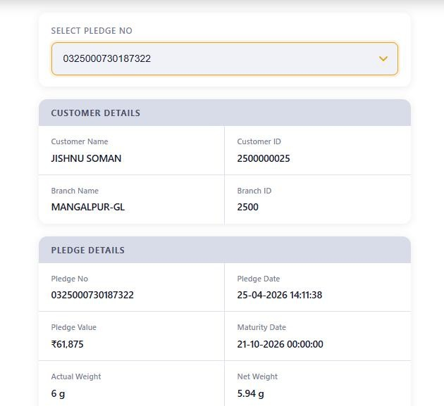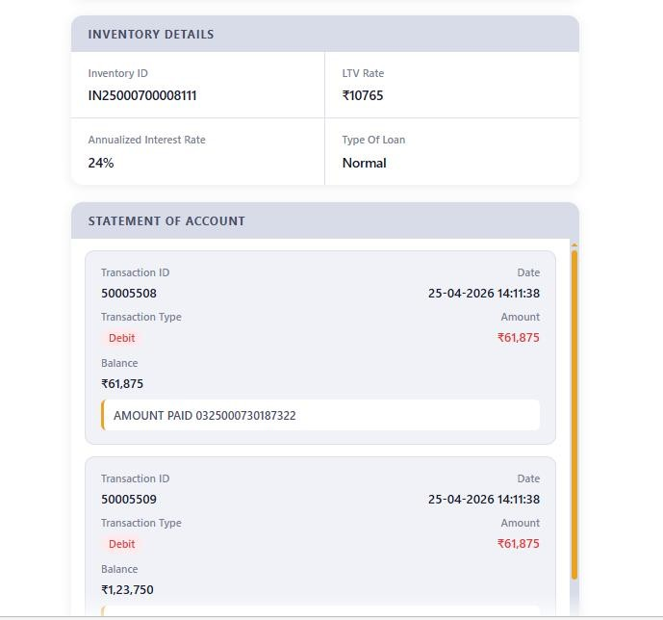

Tables And Procedures Used

Sp_online_queries
Tbl_online_ctran_entries
Cust_tran

API Used:

https://appsbackend.asirvad.com/asirvadgoldloan/oglwebapi/OglWelcomeMessages

https://appsbackend.asirvad.com/asirvadgoldloan/oglwebapi/displayStampDuty

7.24 Current scheme model with differential tenure
Lower tenure or base rate results in higher effective LTV
The table below clearly indicates that customers can avail higher LTV percentages as the tenure decreases.
Details are mentioned Below:
- Tenure options: 3, 6, 9, and 12 months
- Loan Type: Bullet Repayment
- Maximum LTV: 75% / 80% / 85% based on loan amount
- LTV calculation includes principal + interest payable at maturity
LTV for the loan will be determined based on the customer's total loan exposure.
Total consumption loan amount per borrower | Maximum LTV ratio
≤₹2.5 lakh | 85 per cent
> ₹2.5 lakh & ≤ ₹5 lakh | 80 per cent
> ₹5 lakh | 75 per cent

Screenshot

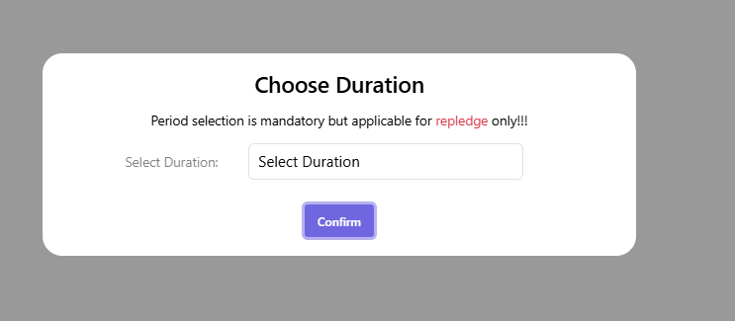

Tables used:

Tbl_duration
Tbl_duration_Select

API used:

https://appsbackend.asirvad.com/asirvadgoldloan/oglwebapi/GetPeriods

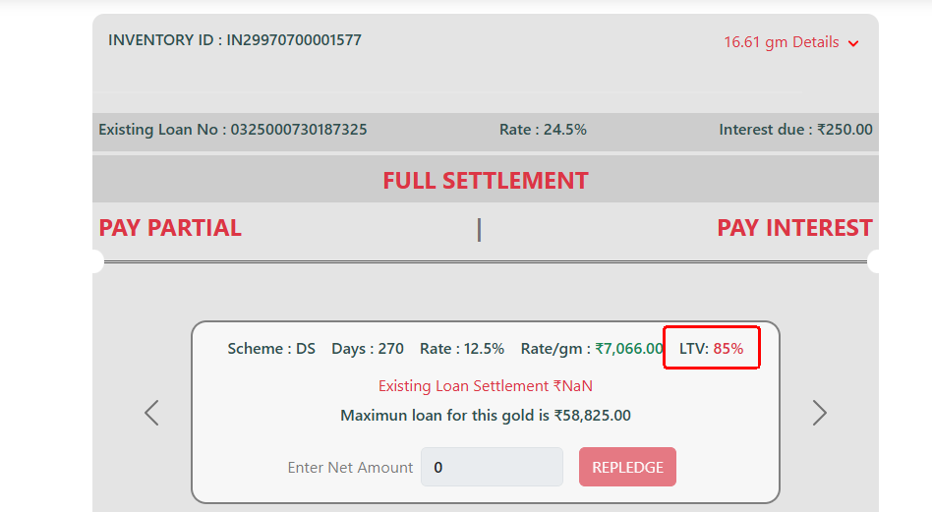

Application | User Role | FunctionID | Screen | Event | Description | Pre-Validations | Host & API | Sample Request | Sample Response
Ogl  Ogl  Ogl  Ogl  Ogl  Ogl | Customer  Customer  Customer  Customer  customer  customer | Auth01,  Auth02,  Auth03,  Auth04 | Login  Login  Login  Login  Repledge  Repledge | Login_button_click  Login button click  Login button click  Login button click  Repledge button click  Repledge button click | Process user authentication  Tocheck whether ogl customer or not | User name should be alpha-numeric, 80 charectors, Alpha Numeric.  Password Should be alpha-numeric, 80 charectors, Alpha Numeric and special charectors.  Custid required | https://amfluat.macom.in/AsirvadGoldloan/OGLLite_MobAppService/Data_Service.asmx/mLoginEncrpt  https://amfluat.macom.in/AsirvadGoldloan/OGLLite_MobAppService/Data_Service.asmx/checkOGLCustomer  https://amfluat.macom.in/AsirvadGoldloan/OGLLite_MobAppService/Data_Service.asmx/GetPledeges  https://amfluat.macom.in/AsirvadGoldloan/OGLLite_MobAppService/Data_Service.asmx/GetSchemeDetails  https://amfluat.macom.in/AsirvadGoldloan/OGLLite_MobAppService/Data_Service.asmx/GetSelectedSchemeDetails  https://amfluat.macom.in/AsirvadGoldloan/OGLLite_MobAppService/Data_Service.asmx/mCustomerProfile | {"Request {"pass":"ZfgZMpPVry3KW5Nn7MnkNA==\n","uid":"0++C7uqaHsRNEDcGtS/m9A==\n","langId":"EN"}}  uniquesessionid=L5PJ9HRFKMSCPU81ZI6C&requestid=DAHYTUKFOPZCUCEHJVWB&langId=EN&custid=2500000101  cusid=2500000101&uniquesessionid=L5PJ9HRFKMSCPU81ZI6C&requestid=NHPXMQTASCIOTLMABLWR&langId=EN  cusid=2500000101&uniquesessionid=L5PJ9HRFKMSCPU81ZI6C&requestid=CLMROWRMLRMIFYGDBMDA&langId=EN&pledgeno=0325000700003056  cusid=2500000101&uniquesessionid=L5PJ9HRFKMSCPU81ZI6C&requestid=OFFKPTXXVAJFVRJXQGER&langId=EN&plno=0325000700003056&schemerow=SX*3520.00*365*28%25*31680.0*1000.0  cusid=2500000101&uniquesessionid=L5PJ9HRFKMSCPU81ZI6C&requestid=WUGDSYVZPSOAHYFEDDXX&langId=EN | { "Response": {"customerid":"2500000101","customername":"ARUN KUMAR SABAT","branch_id":"2500","custlang":null,"uniquesessid":"L5PJ9HRFKMSCPU81ZI6C","requestid":"DAHYTUKFOPZCUCEHJVWB","status":"111","result":"Success","mpinstatus":"N","bhname":"NIRANJAN SAHOO ","bhmobno":"6374497459","otr_status":"2"}}  {"requestid":"XIXIXADYYCKQLAUULLCH","status":"111","result":"Success"}  [{"invID":"IN25000700002780","pledgeNo":"0325000700003056","itmCount":"1","totStdWeight":"9","totGrossWeight":"9","totStoneWeight":"0","pledgeVal":"25400","settlementVal":"25880","eligibleloanamt":"31680","eligiblebalance":"5800","InvDate":"20-Jun-2023","requestid":"XUVZPTWFNHOXDMZJZQJP","invcolor":"NA","efect_int_rate":"28","reb_msg":"NA"},{"invID":"IN25000700002781","pledgeNo":"0325000700003057","itmCount":"1","totStdWeight":"9","totGrossWeight":"9","totStoneWeight":"0","pledgeVal":"31680","settlementVal":"32192","eligibleloanamt":"31680","eligiblebalance":"0","InvDate":"20-Jun-2023","requestid":"XUVZPTWFNHOXDMZJZQJP","invcolor":"#f60000","efect_int_rate":"28","reb_msg":"NA"} ]  [{"schmName":"SY","lendRate":" 2820.00","duration":" 365","interest":"28%","loanValue":" 25400.00","messg":"MAXIMUM LOAN AVAILABLE IS Rs.200000","maxLoan":"200000","minLoan":"1000","requestid":"YHXWOHYTCVQDXJJMRMMA","oglStatus":"111","oglMsg":"Success","status":"111","result":"Success"},{"schmName":"DS","lendRate":" 2620.00","duration":" 365","interest":"26%","loanValue":" 23600.00","messg":"MAXIMUM LOAN  AVAILABLE","maxLoan":"10000000","minLoan":"1000","requestid":"YHXWOHYTCVQDXJJMRMMA","oglStatus":"111","oglMsg":"Success","status":"111","result":"Success"}]  {"branchId":"2500","schemeName":"SX","eligibleLoanAmt":"31680.0","stampDuty":"0","requestid":"WUGDSYVZPSOAHYFEDDXX","status":"111","result":"Success"}  {"custid":"2500000101","name":"ARUN KUMAR SABAT","phone1":"9061563133","phone2":"9061563133","emailid":"arun123@gmail.com","housename":"AT AHIYAS PO AHIYAS JAJPUR","postoffice":null,"pincode":null,"districtname":null,"statename":null,"branchid":null,"branchname":null,"status":"111","result":"Success","requestid":"KNTTVEASWBKXRPMDOHGI"}
ogl | customer |  | Repledge | Repledge button click |  |  | https://amfluat.macom.in/AsirvadGoldloan/OGLLite_MobAppService/Data_Service.asmx/mLoanDetails | cusid=2500000101&uniquesessionid=L5PJ9HRFKMSCPU81ZI6C&requestid=KNTTVEASWBKXRPMDOHGI&langId=EN&plno=0325000700003056 | {"PledgeNo":"0325000700003056","TraDate":"20-Jun-2023","PledgeAmt":"25400","maturityDate":"18-Jun-2024","LastTransactionDate":"20-Jun-2023","closedate":"20-06-2023 00:00:00","balanceAmt":"25400","schemeName":"SY","StatusID":"Live","InvDate":"20-Jun-2023","requestid":"AXGLKXGFNTCEFJNARBFF","status":"111","result":"Success"}
ogl | customer |  | repledge | Repledge button click |  |  | https://amfluat.macom.in/AsirvadGoldloan/OGLLite_MobAppService/Data_Service.asmx/GetCusAccntDetails | cusid=2500000101&uniquesessionid=L5PJ9HRFKMSCPU81ZI6C&requestid=AXGLKXGFNTCEFJNARBFF&langId=EN | {"cusName":"ARUN KUMAR SABAT","cusAccnt":"1269104000015455","bankName":"IDBI BANK","branchName":"MAINPURI","ifsc":"IBKL0001269","cusPhone":"9061563133","cusEmail":"arun123@gmail.com","requestid":"MDKMEPEBDVEVOFJVKAYJ","status":"111","result":"Success"}
ogl | customer |  | repledge | Repledge button click |  |  | https://amfluat.macom.in/AsirvadGoldloan/OGLLite_MobAppService/Data_Service.asmx/GetItemDetails | cusid=2500000101&uniquesessionid=L5PJ9HRFKMSCPU81ZI6C&requestid=MDKMEPEBDVEVOFJVKAYJ&langId=EN&pledgeno=0325000700003056 | [{"brID":"2500","frmID":"3","cusID":"2500000101","itmName":"ANGLEWARE","itmCount":"1","ddnm":"Purity-91.6-Above(22-ct)","actWt":"9","stoneWt":"0","netWt":"9","newActWt":"0","itmID":"7","remark":"kjhbgvc","requestid":"YCXBLYYJRSIBLRVFNLNN","status":"111","result":"Success"},{"brID":"1","frmID":"1","cusID":"","itmName":"TOTAL","itmCount":"1","ddnm":"","actWt":"9","stoneWt":"0","netWt":"9","newActWt":"0","itmID":"1","remark":"","requestid":"YCXBLYYJRSIBLRVFNLNN","status":"111","result":"Success"}]
ogl | customer |  | repledge | Repledge button click |  |  | https://amfluat.macom.in/AsirvadGoldloan/OGLLite_MobAppService/Data_Service.asmx/GetTermsandConditionsDetails | uniquesessionid=L5PJ9HRFKMSCPU81ZI6C&requestid=YCXBLYYJRSIBLRVFNLNN&langId=EN&pledge_no=0325000700003056 | {"requestid":"SLACZLZQJMKQECHYCJVW","status":"111","result":"1. The Borrower has… \t17. The Borrower has read and fully understood the aforesaid terms and conditions and/or have independently had the aforesaid terms and conditions and have completely and fully understood the same to his/her/its satisfaction and also understood that the loan amount and interest rate is associated with my profile and according to the weight, purity, existing market value of gold, LTV and tenor of the loan.\u003cbr\u003e\n\n\u003cp\u003e\u003cu\u003eEligibility For Availing Special Rebate are Mentioned Below.\u003c/u\u003e\u003c/p\u003e\n\u003cp\u003e\nRepledge (Transactions) Frequency Criteria SX scheme\u003c/p\u003e\n\u003cp\u003e\nPay Full Interest \u0026 Minimum 4 Repledges in every 15 days from the inventory created date\t12%\u003cbr\u003e\nPay Full Interest \u0026 Minimum 3 Repledges in every 15 days from the inventory created date\t4%\u003cbr\u003e\nPay Full Interest \u0026 Minimum 2 Repledges in every 15 days from the inventory created date\t2%\u003cbr\u003e\nPay Full Interest \u0026 Minimum 2 Repledges in every 30 days from the inventory created date\t1.5%\u003cbr\u003e\nPay Full Interest \u0026 Minimum 1 Repledge in every 30 days from the inventory created date\t1%\u003cbr\u003e\u003c/p\u003e"}
ogl | customer |  | repledge | Confirm button click |  |  | https://amfluat.macom.in/AsirvadGoldloan/OGLLite_MobAppService/Data_Service.asmx/OglConfirmation | paymethod=1&newpledgeamnt=158200.0&amount=118773&sendOTP=1&cusid=2500000384&uniquesessionid=490ZXNKDXCDJIRCFFAKK&requestid=EFBLTMFCBFARANZNSEVQ&langId=EN&plno=0325000700006300 | {"ifscCode":"SIBL0000312","beneficiaryBank":"SOUTH INDIAN BANK LTD","beneficiaryAccount":"0312053000000783","accountName":"SAVINGS BANK","bankId":"12","custId":"2500000384","serialno":"19","neftStatus":"Approved","mobno":"7561002123","emailId":"afna.vs@mactech.net.in","requestid":"IUFEIRGMJFOAMLXWBXPO","status":"111","result":"Success"}
ogl | customer |  | repledge | Confirm button click |  |  | https://amfluat.macom.in/AsirvadGoldloan/OGLLite_MobAppService/Data_Service.asmx/GetNewloanDetails | cusid=2500000384&pledgeAmount=158200&pledgeno=0325000700006300&uniquesessionid=490ZXNKDXCDJIRCFFAKK&requestid=DOSMNPADRTVEKSZPVUJE&langId=EN | {"stmpduty":"0","netPayment":"40009","requestid":"EFBLTMFCBFARANZNSEVQ","status":"111","result":"Success~amount below 5 Lakh~no need to update pan card"}
ogl | customer |  | repledge | IMPS disbursement time delay rectification |  |  | <add key="IMPSICICIDisbursementUrl" value="https://lms.asirvad.com/mfpubliclmsapi/api/disbursement/ICICIDisbursement" />  <add key="IMPSBOBDisbursementUrl" value="https://lms.asirvad.com/mfpubliclmsapi/api/disbursement/BOBDisbursement" /> | Payment_PutRequest.typeId = 1;  Payment_PutRequest.priority = "0100";  Payment_PutRequest.custId = custid;  Payment_PutRequest.loanId = plno; | apiResponse.status
ogl | customer | PAY PARTIAL | On PAY PARTIAL button click |  |  |  | https://amfluat.macom.in/AsirvadGoldloan/OGLLite_MobAppService/Data_Service.asmx/mPledgeDetails | {"cus_id":"2500000101","pledgeno":"0325000700003057","requestid":"SLACZLZQJMKQECHYCJVW","uniquesessionid":"L5PJ9HRFKMSCPU81ZI6C","langId":"EN"} | {"Processing_Charge":"12","Interest_Total":"500","Interest_Rebate":"83","Interest_Amount":"583","Full_Total":"32192","Full_Rebate":"83","Principle_Amount":"31680","Part_MinAmount":"49.00","Part_MaxAmount":"31680","paymentModeStatus":"full interest/full settlement/part payment options are available","requestid":"YKHEFEZBRQTKNWIMJAGD","status":"111","result":"Success","loanval":"31680","minpay":"12","scheme":"SX","duration":" 365","int_rate":"28%","Eligibility":"True","extend":"False","lendRate":" 3520.00","maxPay":"31192"}
ogl | customer | PAY PARTIAL | On PAY PARTIAL button click |  |  |  | https://amfluat.macom.in/AsirvadGoldloan/OGLLite_MobAppService/Data_Service.asmx/mPartPayAmountUpdate | cusid=2500000101&partamt=50&pledge_no=0325000700003057&requestid=YKHEFEZBRQTKNWIMJAGD&uniquesessionid=L5PJ9HRFKMSCPU81ZI6C&langId=EN | {"requestid":"RCHIPONLPLHUYOCSGZUB","status":"111","result":"Success"}
ogl | customer | PAY PARTIAL | On PAY PARTIAL button click |  |  |  | https://amfluat.macom.in/AsirvadGoldloan/OGLLite_MobAppService/Data_Service.asmx/mPartPayAmountUpdate | cusid=2500000101&partamt=480&pledge_no=0325000700003056&requestid=IVTEBLTMJEIYGUBQEDVS&uniquesessionid=L5PJ9HRFKMSCPU81ZI6C&langId=EN | {"amount":"480","cus_id":"2500000101","paymenttype":"3","paymethod":"18","plno":"0325000700003056","requestid":"DZPTUMRWJUKWLRAQOECO","uniquesessionid":"L5PJ9HRFKMSCPU81ZI6C","langId":"EN"}
 |  |  |  |  |  |  | https://amfluat.macom.in/AsirvadGoldloan/OGLLite_MobAppService/Data_Service.asmx/mGetServiceCharge | {"amount":"512","cus_id":"2500000101","paymenttype":"3","paymethod":"18","plno":"0325000700003057","requestid":"SCMBIMBAECUTMBQCRUPZ","uniquesessionid":"L5PJ9HRFKMSCPU81ZI6C","langId":"EN"} | {"ServiceCharge":"0","TotalAmount":"512","requestid":"UBTUACPKAAONWJDAPJIU","status":"111","result":"Success"}
ogl | CUSTOMER | PAY INTEREST | PAY INTEREST button click |  |  |  | https://amfluat.macom.in/AsirvadGoldloan/OGLLite_MobAppService/Data_Service.asmx/mLoanDetails | {"cusid":"2500000101","plno":"0325000700003056","requestid":"NFFDPAAAXJQTFLGYDTRB","uniquesessionid":"L5PJ9HRFKMSCPU81ZI6C","langId":"EN"} | {"PledgeNo":"0325000700003056","TraDate":"20-Jun-2023","PledgeAmt":"25400","maturityDate":"18-Jun-2024","LastTransactionDate":"20-Jun-2023","closedate":"20-06-2023 00:00:00","balanceAmt":"25400","schemeName":"SY","StatusID":"Live","InvDate":"20-Jun-2023","requestid":"NJRFAWEOKSMCLAEDLSMA","status":"111","result":"Success"}
 |  |  |  |  |  |  | https://amfluat.macom.in/AsirvadGoldloan/OGLLite_MobAppService/Data_Service.asmx/mPledgeDetails | {"cus_id":"2500000101","pledgeno":"0325000700003056","requestid":"NJRFAWEOKSMCLAEDLSMA","uniquesessionid":"L5PJ9HRFKMSCPU81ZI6C","langId":"EN"} | {"Processing_Charge":"12","Interest_Total":"468","Interest_Rebate":"0","Interest_Amount":"468","Full_Total":"25880","Full_Rebate":"0","Principle_Amount":"25400","Part_MinAmount":"292.00","Part_MaxAmount":"25368","paymentModeStatus":"full interest/full settlement/part payment options are available","requestid":"IVTEBLTMJEIYGUBQEDVS","status":"111","result":"Success","loanval":"25400","minpay":"12","scheme":"SY","duration":" 365","int_rate":"28%","Eligibility":"True","extend":"False","lendRate":" 2820.00","maxPay":"24880"}
 |  |  |  |  |  |  | https://amfluat.macom.in/AsirvadGoldloan/OGLLite_MobAppService/Data_Service.asmx/mPartPayAmountUpdate | cusid=2500000101&partamt=480&pledge_no=0325000700003056&requestid=IVTEBLTMJEIYGUBQEDVS&uniquesessionid=L5PJ9HRFKMSCPU81ZI6C&langId=EN | {"requestid":"DZPTUMRWJUKWLRAQOECO","status":"111","result":"Success"}
 |  |  |  |  |  |  | https://amfluat.macom.in/AsirvadGoldloan/OGLLite_MobAppService/Data_Service.asmx/mGetServiceCharge | {"amount":"480","cus_id":"2500000101","paymenttype":"3","paymethod":"18","plno":"0325000700003056","requestid":"DZPTUMRWJUKWLRAQOECO","uniquesessionid":"L5PJ9HRFKMSCPU81ZI6C","langId":"EN"} | {"ServiceCharge":"0","TotalAmount":"480","requestid":"FYJZCPYSJYSKZTIHPPNO","status":"111","result":"Success"}
ogl | customer | set/reset MPIN | Mpin set |  |  |  | https://amfluat.macom.in/AsirvadGoldloan/OGLLite_MobAppService/Data_Service.asmx/mcustomerMPINrequest | cusid=2500000101&uniquesessionid=L5PJ9HRFKMSCPU81ZI6C&sendOTP=1&requestid=LSDULPCKRURQSTZSJRAR&langId=EN | {"requestid":"FQSWKGFVZPWWPAPYEDQZ","status":"111","result":"Success"}
 |  |  |  |  |  |  | https://amfluat.macom.in/AsirvadGoldloan/OGLLite_MobAppService/Data_Service.asmx/mcustomerMPINotpVerification | cusid=2500000101&uniquesessionid=L5PJ9HRFKMSCPU81ZI6C&otp=488431&requestid=FQSWKGFVZPWWPAPYEDQZ&langId=EN | {"requestid":"WLJWRLYBRFHNYDRWYJQK","status":"101","result":"OTP verified"}
 |  |  |  |  |  |  | https://amfluat.macom.in/AsirvadGoldloan/OGLLite_MobAppService/Data_Service.asmx/mcustomerMPINgeneration | {"cusid":"2500000101","deviceid":"b3068d065e8448fd","devicetype":"Android","MPIN":"0000","reqtype":"1","requestid":"WLJWRLYBRFHNYDRWYJQK","uniquesessionid":"L5PJ9HRFKMSCPU81ZI6C","langId":"EN"} | {"requestid":"EZHHUHPXXQRGDJOWCQXB","status":"111","result":"Successfully generated and saved MPIN"}
 |  |  |  |  |  |  | https://amfluat.macom.in/AsirvadGoldloan/OGLLite_MobAppService/Data_Service.asmx/mcustomerMPINlogin | {"deviceid":"7ezAU92ywoh/fJRmOnJ3pvhows/rcRrZtVS5U5pjc2k=\n","MPIN":"A5/5NyLpqOhfUqdXjbkcIA==\n","langId":"EN"} | {"customerid":"2500000101","customername":"ARUN KUMAR SABAT","branch_id":"2500","custlang":null,"uniquesessid":"ZT2JVNSXK4S1F0GMY8BC","requestid":"BIXJOSJZPCUNXTWHPCTW","status":"111","result":"Success","mpinstatus":"Y","bhname":"NIRANJAN SAHOO ","bhmobno":"6374497459","otr_status":"2"}
 |  |  |  |  |  |  | https://amfluat.macom.in/AsirvadGoldloan/OGLLite_MobAppService/Data_Service.asmx/mLogout | {"loginid":"2500000101","requestid":"EZHHUHPXXQRGDJOWCQXB","uniquesessionid":"L5PJ9HRFKMSCPU81ZI6C","langId":"EN"} | {"requestid":null,"status":"111","result":"Successfully logout"}
repledge | Onlinepayment reciept | repledge | Onlinepayment reciept |  |  |  | https://amfluat.macom.in/AsirvadGoldloan/OGLLite_MobAppService/Data_Service.asmx/online_payment_receipt | cusid=2500000028&pledgeno=0325000700008238&trans_no=175087060ebf0f79cf403c&payment_type=1&amount=1082&payment_date=2024%2F12%2F03&payment_status=success&langType=EN | :{"Cusid":"2500000028","status":"111","result":"success"}
ogl | Pan updation | Pan updation | Pan updation |  |  |  | https://amfluat.macom.in/Asirvadgoldloan/mfpublickycapi/api/pan | {"empId":"2500000354","firmId":"1","pan":pan":"RZQPS4561A"} | {"status":"SUCCESS","apiStatus":"COMPLETED","responseMsg":"SUCCESS","statusCode":0,"data":[{"pan_number":"RZQPS4561A","pan_status":"VALID","last_name":"SANTHOSH","first_name":"AKHIL","middle_name":"KOZHIPARAMBIL","pan_holder_title":"","pan_last_updated":""}],"errorList":null}
ogl | declaration | Declaration for excess portion | Declaration for excess portion |  |  |  | https://amfluat.macom.in/AsirvadGoldloan/OGLLite_MobAppService/Data_Service.asmx/get_declaration_for_excess_portion | cust_id=2500000354&pledge_no=0325000700008274&existing_amt=75308&req_amt=448792.0&declaration=success&langId=EN | {"status":"1","result":"Saved"}
ogl | Penny drop | Penny drop | Pennydrop confirmation | ogl |  |  | https://amfluat.asirvad.com/AsirvadGoldloan/OGLLite_MobAppService/Data_Service.asmx/CustomerName_Check | acc_holder_name=THAMJIDHA%20T%20N&cust_id=2500004475 | {"percentage":"69.23","status":"0","result":"Bank account details not matched, kindly contact your gold loan branch."}
ogl | Penny drop | Penny drop | Pennydrop confirmation |  |  |  | https://amfluat.macom.in/Asirvadgoldloan/mfpublickycapi/api/bank | {"account":"1922120000197","consent":"","empId":"16894","firmId":"3","ifsc":"CNRB0001922"} | {"status":"SUCCESS","apiStatus":"COMPLETED","responseMsg":"SUCCESS","statusCode":0,"data":{"beneName":"RONISH C WILSON","bankRef":"414516592312","account":null,"ifsc":null,"status":"VERIFIED","remark":"Transaction Successful"},"errorList":null}
ogl | Penny drop | Penny drop | Pennydrop confirmation |  |  |  | https://amfluat.macom.in/AsirvadGoldloan/customer_public/api/banks/banks | {"applicationId":0,"bankDetails":{"accountHolderName":"RONISH C WILSON","accountNo":"+M/Yt8F9A2x0u1wDiAuQEw==\n","bankName":"CANARA BANK","branchName":"PERUMPILAVU","customerId":"2500001108","editFlag":0,"ifsc":"krr9Cscvm0fBVs8sy/Ey9w==\n","typeId":1,"userId":16894,"verificationResponse":{"apiStatus":"COMPLETED","data":{"bankRef":"414516592312","beneName":"RONISH C WILSON","remark":"Transaction Successful","status":"VERIFIED"},"responseMsg":"SUCCESS","status":"SUCCESS"},"verificationStatus":1},"stageId":1,"trackerId":10355966} | {"status":"SUCCESS","apiStatus":"COMPLETED","responseMsg":"Bank account details successfully Updated.Need Approval From HO","authToken":null,"trackreValue":null,"data":{"isDataAvailable":true,"message":"Bank account details successfully Updated.Need Approval From HO","messageStatus":"1","trackerId":null,"flag":null,"timeStamp":null},"errorList":null}
ogl | Penny drop | Penny drop | Pennydrop confirmation |  |  |  | https://amfluat.macom.in/AsirvadGoldloan/customer_public/api/Photo/AddBankOgl | {"custId":"2500001108","oglbankphoto":"/9j/4AAQSkZJRgABAQAAAQABAAD/4gIoSUNDX1BST0ZJTEUAAQEAAAIYAAAAAAQwAABtbnRyUkdC\nIFhZWiAAAAAAAAAAAAAAAABhY3NwAAAAAAAATYBAmFhAUIEx6oIEAguANE2KCwVIwDKwH//2Q==\n"} | {"status":"SUCCESS","apiStatus":"COMPLETED","responseMsg":"Ogl Conversion approval is success","authToken":null,"trackreValue":null,"data":null,"errorList":null}
ogl | Penny drop | Penny drop | Pennydrop confirmation |  |  |  | https://amfluat.macom.in/AsirvadGoldloan/OGLLite_MobAppService/Data_Service.asmx/otr_customer_bank_details_submit | branch_id=2500&custName=ROSHAN%20D%20STANLY&uniquesessionid=ZFB8WG0GAAYFZHTIY8YP&requestid=RNJFTQFJGTWPGTRSDIVS&cusid=2500001108&langId=EN | {"requestid":"","status":"111","result":"success"}
 |  |  |  |  |  |  | https://amfluat.macom.in/AsirvadGoldloan/OGLLite_MobAppService/Data_Service.asmx?op=Bank_Verification_BH | Cust_id:2500004475  Accountno:6546464  IFSC: 5464645 | {"requestid":"","status":"111","result":"success"}
ogl | Penny drop | Penny drop | Pennydrop confirmation |  |  |  | https://amfluat.macom.in/AsirvadGoldloan/OGLLite_MobAppService/Data_Service.asmx/penny_customer_bank_details_submit | branch_id=2500&custName=ROSHAN%20D%20STANLY&uniquesessionid=ZFB8WG0GAAYFZHTIY8YP&requestid=RNJFTQFJGTWPGTRSDIVS&cusid=2500001108&langId=EN | {"requestid":"","status":"111","result":"success"}
ogl | Full settlement | Full settlement | Full payment through online |  |  |  | https://amfluat.asirvad.com/AsirvadGoldloan/OGLLite_MobAppService/Data_Service.asmx/mPledgeDetailsFullsettlement | {"cus_id":"2500000090","pledgeno":"0325000700010171","requestid":"CXJWNMCHOAYUKTXKEJFH","uniquesessionid":"OZ5I6ROFNHLABMGUTB8L","langId":"EN"} | {"Processing_Charge":"12","Interest_Total":"58246","Interest_Rebate":"0","Interest_Amount":"58246","Full_Total":"158461","Full_Rebate":"0","Principle_Amount":"100000","Part_MinAmount":"235.00","Part_MaxAmount":"157746","paymentModeStatus":"full interest/full settlement/part payment options are available","requestid":"SADSFQNTSQQETLLJRPQF","status":"111","result":"Success","loanval":null,"minpay":null,"scheme":null,"duration":null,"int_rate":null,"Eligibility":"False","extend":"True","lendRate":null,"maxPay":null}
ogl | Full settlement | Full settlement | Full payment through online |  |  |  | https://amfluat.macom.in/AsirvadGoldloan/OGLLite_MobAppService/Data_Service.asmx/mGetServiceCharge | {"amount":"512","cus_id":"2500000101","paymenttype":"3","paymethod":"18","plno":"0325000700003057","requestid":"SCMBIMBAECUTMBQCRUPZ","uniquesessionid":"L5PJ9HRFKMSCPU81ZI6C","langId":"EN"} | {"ServiceCharge":"0","TotalAmount":"512","requestid":"UBTUACPKAAONWJDAPJIU","status":"111","result":"Success"}
ogl | Full settlement | Full settlement | Full payment through online |  |  |  | https://amfluat.asirvad.com/AsirvadGoldloan/OGLLite_MobAppService/Data_Service.asmx/payuinputdata | {"amount":"158461","cusid":"2500000090","plno":"0325000700010171","requestid":"NKMJQWTSZOTXAMLCNCJV","uniquesessionid":"OZ5I6ROFNHLABMGUTB8L","langId":"EN"} | {"hash":"3a6bafe77bc54f4dc0362e4e8d3de24a54834908c5270981ce5dfef0ac1de70ad71af84b8ff327dce8ecb1c8efdcb8460bdf8b5b28fe9937431751b49d9ab0b9","txnid":"177965614cd6b6ca700ae4","key":"gRHqLN","salt":"gK3cNOd7","amount":"158258","firstname":"ANILA MOHAN","email":"anumol.james@mactech.net.in","phone":"7561002123","productinfo":"GoldLoan","action":"https://test.payu.in/_payment","requestid":"IDQSBDKOBFGPSFQJDWYC","status":"111","result":"Success"}
ogl | Full settlement | Full settlement | Full payment through online |  |  |  | https://amfluat.asirvad.com/AsirvadGoldloan/OGLLite_MobAppService/Data_Service.asmx/mFinalCheck | {"amount":"158258","email":"anumol.james@mactech.net.in","firstname":"ANILA MOHAN","key":"gRHqLN","productinfo":"GoldLoan","salt":"gK3cNOd7","status":"Successful","txnid":"177965614cd6b6ca700ae4","udf1":"","udf10":"","udf2":"","udf3":"","udf4":"","udf5":"","udf6":"","udf7":"","udf8":"","udf9":"","requestid":"IDQSBDKOBFGPSFQJDWYC","uniquesessionid":"OZ5I6ROFNHLABMGUTB8L","langId":"EN"} | {"Hash":"2549e2eee7f9ae1e2b61038d005ad3d53ebdf3b511efdef8ca7b5788ff246ed2dfae95fbd81a54f7c326efac1c24adfdb44994b08b1a20f1e5c1df53589d897d","requestid":"BFFBKOMLPHCEVYXGLSBZ","status":"111","result":"Success"}
ogl | Full settlement | Full settlement | Full payment through online |  |  |  | https://amfluat.asirvad.com/AsirvadGoldloan/OGLLite_MobAppService/Data_Service.asmx/mTransaction | {"amount":"158258","paymode":"2","payutransactionid":"177965614cd6b6ca700ae4","pledgeno":"0325000700010171","requestid":"BFFBKOMLPHCEVYXGLSBZ","uniquesessionid":"OZ5I6ROFNHLABMGUTB8L","langId":"EN"} | {"requestid":"AOLBKTVTRZLFPAJSSCDQ","status":"111","result":"Success"}

8. Data Base Schema Design

8.1. Table Relationship Design
8.2. Table Structures And Views

8. 1. Sample Table Structure
Table Name: TBL_ONLINE_FPASSWORD_OTPLOG
Name | Type | Comments
CUST_ID | VARCHAR2(14) | Customer id
MOB_NO | VARCHAR2(20) | Mobile number
EMAIL_ID | VARCHAR2(50) | Email id
OTP | VARCHAR2(10) | otp
TRA_DT | DATE | Tra date
MSG_ID | VARCHAR2(300) | Message id
STATUS | NUMBER | status
SEND_STATUS | NUMBER | Otp send status
HIT_COUNT | VARCHAR2(3) | Hit count

Registration and forgot password OTP are saved in this table.

Table Name: tbl_online_customer_details
Name | Type | Comments
CUST_ID | VARCHAR2(14) | Customer id
CUST_NAME | VARCHAR2(40) | Customer name
BRANCH_ID | NUMBER(4) | Branch id
BRANCH_NAME | VARCHAR2(50) | Branch name
ADDRESS | VARCHAR2(130) | address
PH1 | VARCHAR2(20) | Phone number 1
PH2 | VARCHAR2(20) | Phone number 2
EMAIL_ID | VARCHAR2(50) | Email id
UNIQUELOGINID | VARCHAR2(16) | Unique login id
EMAIL_STATUS | NUMBER(4) | Email status
EMAIL_UP_DATE | DATE | Email up date
Customer registration details are saved here.

Table Name:tbl_language_rqst
Name | Type | Comments
RES_MSG_ID | VARCHAR2(20) | Message id
LANG_ID | VARCHAR2(10) | Language id
RES_MSG | NVARCHAR2(2000) | message
Multiple language details are saved here.

Table Name: tbl_online_login_register
Name | Type | Comments
COL_SESS_ID | VARCHAR2(60) | Session id
COL_CUST_ID | VARCHAR2(100) | Customer id
COL_LOGINTIME | DATE | Login time
COL_LOGOUTTIME | DATE | Logout time
COL_LOG_DT |  | Log date
COL_REQFULLDTLS | VARCHAR2(4000)
COL_REQBROWSER
CUST_ID | VARCHAR2(14) | Customer id
REQUEST_ID | VARCHAR2(60) | Request id

Login session id, request id, logged in and out time etc. saved here.

Table Name : TBL_ONLINE_CTRAN_ENTRIES
Name | Type | Comments
COL_TRANSACTION_ID | VARCHAR2(14) | Transaction id
COL_PLEDGENO | VARCHAR2(16) | Pledge number
COL_INTAMT | NUMBER(10,2) | amount
COL_OTHERCHARGE | NUMBER(10,2) | Other charges
COL_POSTAGE | NUMBER(10,2) | postage
COL_INTWAIVE | NUMBER(10,2)
COL_REBATE | NUMBER(10,2) | rebate
COL_BALANCE | NUMBER(10,2) | Principal Balance
COL_TRA_DATE | DATE | Tra date
COL_PAY_MODE | NUMBER | 1 - Interest Payment, 2 - Full Payment , 3-Patpayment with Principal ,4-repledge
COL_MODULE | NUMBER(1) | 1 - Online Payment , 2 -Mobile Payment
COL_STATUS | NUMBER(1) | 1 - Payment Under Progress,2 - Payment Recived,3 - Payment Failed, 8 -Payment in transit,4-Refunded,5-Wait for manual Confirmation,  6-Need to Refund
COL_PAYMODE | NUMBER(2) | 1-Debit Card,2-Net Banking-15-upi
COL_SER_CHARGE1 | NUMBER(10,2)
COL_SER_CHARGE | NUMBER(10,2)
COL_INT_WAIVE_NEW | NUMBER(10,2)
COL_OPTION | NUMBER | 1-Registered Customer Payment,2-Express Pay
COL_PART_PAY_AMT | NUMBER(10,2)
COL_MIN_AMT | NUMBER(10,2)
COL_CLOSE_DATE | DATE
COL_REP_AMT | NUMBER(10,2) | Re pledge difference amount credited to customer
COL_REP_NEW_AMT | NUMBER(10,2) | Pledge value of new pledge number
BANK_CODE | VARCHAR2(8)
NEW_PLEDGE_NO | VARCHAR2(20)
PAYMENT_GATEWAY | VARCHAR2(8)
DISB_STR | VARCHAR2(4000)
COL_ADV_CHARGE | NUMBER(10,2)
TRADATE | DATE
COL_REP_PAY | NUMBER
INVENTORY | VARCHAR2(20)
CUST_ID | VARCHAR2(14)
REP_STATUS | NUMBER

Every transaction’s details including re pledge are saved here.

Table Name: tbl_online_tran_track
Name | Type | Comments
PLNO | VARCHAR2(16) | pledgenumber
TRA_ID | VARCHAR2(14) | Tra id
TRA_DT | DATE | Tra date
AMOUNT | NUMBER(10,2) | Amount
STATUS | NUMBER(2) | status
TRA_START_TIME | DATE | Tra start time
TRA_END_TIME | DATE | Tra end time
PAYU_TRA_ID | VARCHAR2(60) | Payu tra id
EMAIL_ID | VARCHAR2(500)
PHONE_NO | VARCHAR2(15)
MSGHASH | VARCHAR2(4000)

Pay U transaction id and pay U amount details are saved here.

Table Name : TBL_OGL_PLEDGE_BLOCK
Name | Type | Comments
PLEDGE_NO | VARCHAR2(16) | Pledge number
TRADT | DATE | Current date
STATUS | NUMBER(1) | 0-unblocked,1-blocked by H O,2-blocked by customer
ENTER_BY | VARCHAR2(20) | Emp id who blocked
REASON | VARCHAR2(150) | reson
REMOVE_BY | VARCHAR2(20) | Employee id who removed block
REMOVE_DT | DATE | Removed date
REASON_UNBLOCK | VARCHAR2(150) | Reason for unblock
INVENTORY | VARCHAR2(20) | Inventory blocked by customer for sms banking

Table Name: TBL_ONLINE_OTP_LOG
Name | Type | Comments
TRID | VARCHAR2(14) | Tr id
CUST_ID | VARCHAR2(14) | Customer id
PLEDGE_NO | VARCHAR2(16) | Pledge number
MOB_NO | VARCHAR2(20) | Mobile number
EMAIL_ID | VARCHAR2(50) | Email id
OTP | VARCHAR2(10) | otp
TRA_DT | DATE | Tra date
MSG_ID | VARCHAR2(300) | Message id
STATUS | VARCHAR2(3) | status
HIT_COUNT | VARCHAR2(3) | Hit count

Table Name : TBL_ONLINE_EXCEPTION_MSG
Name | Type | Comments
TRA_ID | VARCHAR2(14) | Tra id
PLEDGE_NO | VARCHAR2(25) | Pledge number
EXP_MSG | VARCHAR2(2000) | Exception message
EXP_DATE | DATE | Exception date
PAYMENT_GATEWAY | VARCHAR2(20) | Payment gate way

Table Name : TBL_PAYU_COMPLETED
Name | Type | Comments
TRA_ID | VARCHAR2(14) | Tra id
PLEDGE_NO | VARCHAR2(16) | Pledge number
TRADATE | DATE | Tra date

Table Name : tbl_online_payu_trans_updation
Name | Type | Comments
TRANSACTIONID | VARCHAR2(20) | Transaction id
CUSTID | VARCHAR2(14) | Customer id
PLEDGENO | VARCHAR2(16) | Pledge number
AMOUNT | NUMBER(10,2) | amount
STATUS | NUMBER(2) | status
TRADT | DATE | Tra date
RESULTMSG | VARCHAR2(800) | Result message
ERRORSTATUS | NUMBER(2) | 0-success,1-error:validation catched
REPORTINGSTATUS | NUMBER(2) | 1-Reported to operations,0-Not reported

Table Name : TBL_OGL_REPLEDGE_MAIL_OPT
Name | Type | Comments
CUST_ID | VARCHAR2(14) | CUSTOMER ID
OPT_STATUS | VARCHAR2(16) | - UNSUBSCRIBED
TRA_DT | DATE | Tra date

Table Name: | TBL_OGL_CONSOLIDATE_KFS_MAIL
Name | Type |  |  |  |  |  | Comments
CUST_ID | VARCHAR2(16) |  |  |  | CUSTOMER ID
PLEDGE_NO | VARCHAR2(20) |  |  |  | PLEDGE NUMBER
MODULE_ID | NUMBER |  |  |  | 1- OGL APP, 4- OGL WEB
MAIL_ID | VARCHAR2(40) |  |  |  | MAIL
STATUS | NUMBER |  |  |  | 1- success,0- exception
TRA_DT | DATE |  |  |  | TRA DATE

Table Name: TBL_OGL_PENNYDROP_CUSTOMER_DTL
Name | Type | Comments
cust_id | VARCHAR2(50) | Customer id
status | NUMBER | Success-1 else 0
cust_name | VARCHAR2(50) | Customer name
acc_holder_name | VARCHAR2(50) | Account holder name
name_match | NUMBER(10,2) | Name match percentage
tra_dt | DATE | date

Table Name: TBL_OGL_EXCESS_PORTION_DECLARATION

Name | Type | Comments
Cust_id | VARCHAR2(14) | Cust_id
Pledge_no | VARCHAR2(16) | Pledge number
Existing_amt | Number(10,2) | Existing loan amount
Req_amt | Number(10,2) | Requested amount
Declaration | Varchar(4000) | declaration
Tra_dt | date | date

Table Name: TBL_OGL_PAYMENT_RECEIPT_EMAIL

Name | Type | Comments
custid | VARCHAR2(16) | Cust id
pledgeno | VARCHAR2(20) | Pledge number
trans_no | VARCHAR2(50) | Transaction number
amount | VARCHAR2(50) | Amount
payment_date | DATE | Payment date
payment_type | VARCHAR2(50) | Payment type
payment_status | VARCHAR2(50) | Payment status
emaild | VARCHAR2(40) | Email id
Status | VARCHAR2(4) | Status
Tra_dt | DATE | Tra date

8. 2. Other Related Processes

Views

Types

8.3. Triggers, Procedures and Functions

8.3.1. Triggers

8.3.2. Stored Procedures

VCS PATH: $/AML_GLOAN_DB/PROCEDURES/SP_ONLINE_QUERIES.sql

8.3.3. Functions

